**Overcoming Anxiety and Worry**

**Contents**

|  |  |
| --- | --- |
| Helpful contacts to keep safe | 4 |
| Completing the questionnaires | 5 |
| **Session 1** |  |
| What is anxiety? | 6 |
| What are the signs of anxiety? | 7 |
| The five areas model | 8-9 |
| Values | 10-11 |
| Goal setting | 12-14 |
| Between session tasks | 15 |
| End of session review | 16 |
| **Session 2** |  |
| Start of session review | 19 |
| Identifying physical symptoms of anxiety | 20 |
| Fight, Flight, Freeze | 21-23 |
| Relaxation | 24-26 |
| Between session tasks | 27 |
| End of session review | 28 |
| **Session 3** |  |
| Start of session review | 31 |
| What is worry? | 32-33 |
| Worry Management | 34-35 |
| Worry Diary | 36 |
| Worry tree | 37 |
| Letting go of worries | 38 |
| Worry time | 39-41 |
| Worry free time | 42 |
| Problem Solving | 43-46 |
| Between session tasks | 47 |
| End of session review | 48 |
| **Session 4** |  |
| Start of session review | 51 |
| What keeps anxiety going? | 52-53 |
| Facing your fears | 54 |
| How can we overcome avoidance? | 55-56 |
| Common choices that impact our mood | 57 |
| Health Behaviour Change | 58 |
| Why is sleep so important | 59 |
| Between session tasks | 60 |
| End of session review | 61 |
| **Session 5** |  |
| Start of session review | 64 |
| Moving forward after the course | 65 |
| Five areas | 66 |
| Wellbeing action plan | 68-69 |
| Reviewing goals | 70 |
| Next steps | 71 |
| End of session review | 72 |

**Helpful contacts to keep safe**

**Need to contact Sheffield Talking Therapies?**

You can contact Talking Therapies Admin on **0114 226 4380. Please let us know if you are unable to attend a session or you would like to discuss other treatment options.**

**Need urgent help?**

If your mood is particularly low and you are concerned about your safety, please use the following information:

* Speak with friends and family for support
* Please make an appointment to **speak to your GP** as soon as possible
* **NHS 111 – select option for mental health support 123** (24 hours a day, 7 days a week)
* Samaritans: **116 123**
* Rethink: **0808 8010440**
* A blue silhouette of a head with a heart in the middle

  Description automatically generatedAlways call **999** in an emergency

**Completing the questionnaires**

Before each session we will send you questionnaires by email or text.

These questionnaires include the PHQ-9 which looks at symptoms of depression and the GAD-7 which looks at symptoms of anxiety.

These questionnaires can help measure the severity of your mood and it can show any changes in your mood during your treatment.

For each symptom, have a think about **how often** the symptom has bothered you over the last **two weeks** in total.

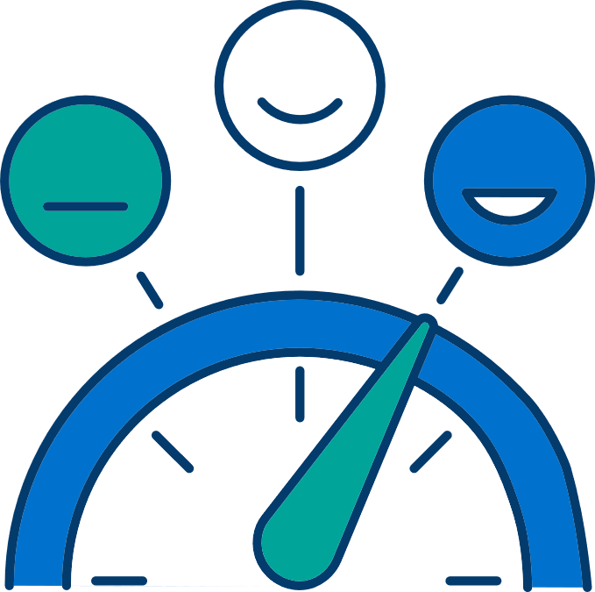

|  |
| --- |
|  |

For each questionnaire, you can add up each number scored to provide you with a total score.

**The PHQ-9 is out of 27.   
The GAD-7 is out of 21.**

|  |  |  |  |  |  |
| --- | --- | --- | --- | --- | --- |
|  | **Session 1** | **Session 2** | **Session 3** | **Session 4** | **Session 5** |
| **PHQ-9**  Depression |  |  |  |  |  |
| **GAD-7**  Anxiety |  |  |  |  |  |

Add up your total each week to watch your progress throughout the course.

**1st**

**Session**

**What is Anxiety?**

“Anxiety is a feeling of unease, worry or fear. Everyone feels anxious at some point in their life, but for some people it can be an ongoing problem”.

We all experience anxiety from time to time. You might feel anxious before sitting an exam, during an interview or when having a medical test. At these times feeling some anxiety would be expected and is perfectly normal. However, when the feelings of anxiety and worries are having a constant impact on your daily life, it can become difficult to manage.

Anxiety can take many forms. For example:

* people who are worried by their health may experience **health anxiety**
* people with a specific fear of open spaces and going outside may experience **agoraphobia**

This course will mainly focus on the type of anxiety called **generalised anxiety disorder (GAD)**. GAD can be explained by excessive worrying about day-to-day things.

**What are some of the signs of anxiety that you have noticed?**

**Feelings: Thinking:**

e.g. nervous, worried

e.g. what if I’m late? I don’t know how to cope

**Behaviours: Body:**

e.g. worrying a lot, avoiding going to busy places

e.g. increased heart rate, sweating

**The five** **areas model**

Cognitive Behavioural Therapy (CBT) treatment focuses on the way our thoughts, feelings and behaviours link with each other.

When feeling anxious, it is common to fall into a vicious cycle. In this vicious cycle, our thought processes and behaviour patterns can be unhelpful. They keep anxiety going. The more we think and behave in unhelpful ways, the longer the anxiety will last.

These vicious cycles can also be influenced by the way we interpret different situations. When we feel anxious, we tend to interpret situations negatively. This can lead to unhelpful feelings and behaviours.

When starting CBT, it is helpful to identify your own unhelpful thought patterns and behaviours. This helps you find your vicious cycle. Once you have identified your vicious cycle, you can learn how to break it and make changes.

Here is an example:

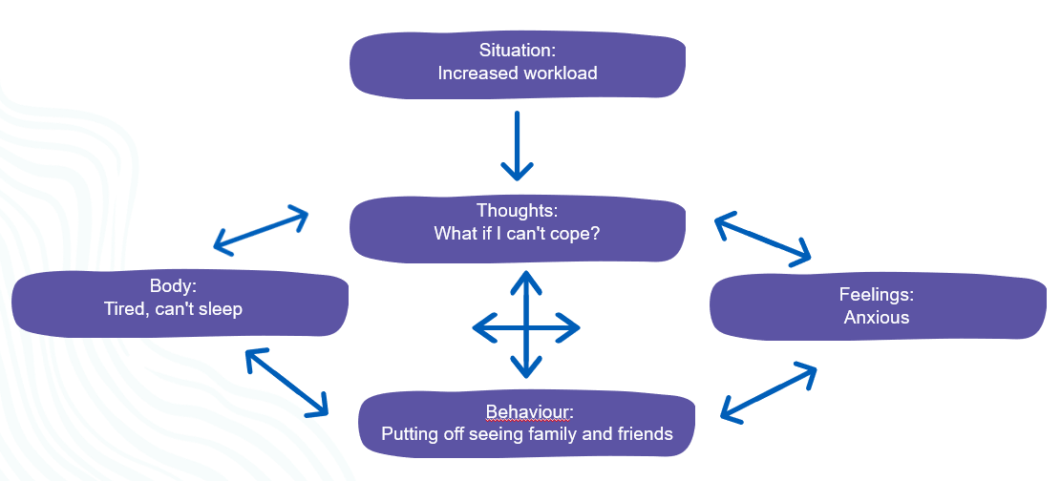

**Completing your five areas**

Situation

Behaviour

Feelings

Body

Thoughts

**Values**

Before you start making changes to improve your mood, it's important to consider what things you value in your life. Think about how you might be living in relation to these values.

**Values** represent the kind of person we want to be and the things we stand for in life. Thinking about values can identify what actions are important to us. We’re also more likely to achieve our goals when they are **valuable**.

Many different values exist in life. The most common values are related to **relationships, spirituality, education, culture and our wellbeing.**

**Complete your value compass**

Arts and culture

Religion/Beliefs

Physical wellbeing

Parenting/caring

Other

Education/work

Friendships

Family/relationships

**Goal setting**

Now you have an idea about what’s important to you and what you’d like to change, it can be helpful to set a goal to work towards. This increases motivation to complete the course of treatment. It also makes it more meaningful.

We can make goals more achievable by using the SMART goal structure. SMART is an acronym for the following:

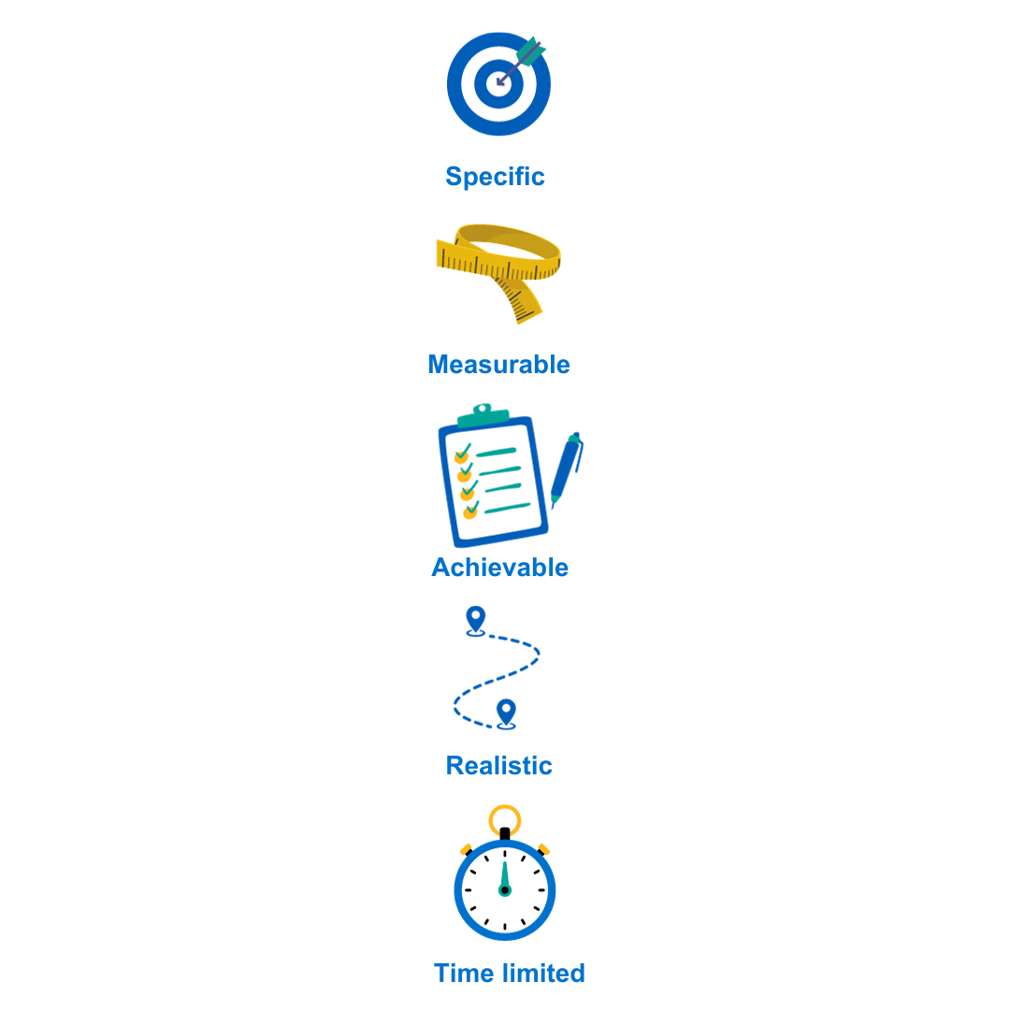

**What do I want to achieve?**

**How will I know I have reached the goal?**

**Can I achieve this goal with the resources I have?**

**Could anyone achieve this goal?**

**When should this goal be completed?**

Using the SMART Goal framework, have a go at setting your own goal for treatment. Have a think about what you’d like to be doing if you were feeling better.

It is important to consider **barriers** to achieving your goal. If there are some barriers, consider what you could put in place to solve them.

**Set a SMART Goal and consider any barriers**

**My SMART goal:**

**What might get in the way?:**

**How can I overcome this?**

**Between Session Tasks**

Each session, you will be set some tasks for the next week based on the information covered. It is important to practice each task regularly over the next week. This will help you begin to see some improvement in your anxiety.

**Session one tasks:**

* **Finish creating your 5 areas model**
* **Finish setting your goals based on your values**
* **Take your first step towards your goal**



**End of session 1 review**

At the end of each session, reflect on what you've learned. Consider how you can apply it to your own situation. Use the prompt questions below to think about what you’re going to spend the next week practicing. Consider some solutions to any barriers that may prevent you making the agreed changes.

* **What did I learn in today’s session?**
* **How can I apply this to my own situation?**
* **What might get in the way of doing this?**
* **How can I stop this from happening?**
* **What am I going to practice from this session?**

**Session 1 - notes**

**2nd**

**Session**

**Start of session 2 review**

It’s helpful to review the practice you have done over the last week. Don’t be disheartened if you haven’t been able to complete all the tasks. Instead, it is helpful to think about what got in the way and consider how to overcome this next time.

**How did you get on with the between-session tasks?**

**How do you feel about this?**

**Did you come across any barriers? How did/will you overcome them?**

**Identifying physical symptoms of anxiety**

Imagine you are woken up in the night by a sudden loud noise. What changes in your body do you notice? Note them on this diagram below.

These symptoms are often frightening and can be extremely uncomfortable. They all relate to the brain’s in-built survival mechanism, known as the Fight, Flight or Freeze Response.

**Fight, flight or freeze**

When the brain thinks a threat is near, it will send messages to the body to go through rapid changes. This ensures self-preservation and survival. This is known as the fight, flight or freeze response. These physical changes are designed to help you physically defend yourself (fight), run for your life (flight) or hide from the threat (freeze).

Imagine you are walking through the woods and a bear comes towards you. The part of your brain responsible for survival will automatically notice this threat. It will send a message throughout your body to rapidly change and ensure you survive. You may turn and run for your life, stand your ground ready to fight or stay perfectly still to not draw attention. The fight flight or freeze response helps you do this immediately to avoid delay.

Most living creatures can trigger the fight, flight or freeze response. It has helped most species evolve and survive for thousands of years. It has been vital for our day-to-day survival. In modern times, humans are less likely to come across dangers. However, the fight, flight, or freeze response is still needed. It may be triggered by actual threats, such as getting out of the way of a car driving dangerously or an aggressive animal.

Problems arise when we try to protect ourselves from **perceived threats**. The fight, flight or freeze response **is automatic**. It will be triggered whenever humans are placed in stressful situations, even when their survival is not in question. This means the response can be triggered by job interviews, on a crowded bus or if you are running late for work. The fight, flight, or freeze response can't tell the difference between perceived and actual threats. This can leave us feeling extremely anxious even when there is no physical danger. This can feed into the cycle of anxiety.

The feeling of anxiety is the rapid changes happening in the body. Some common anxiety symptoms are linked to the fight, flight or freeze response below:

All of the above symptoms are **completely normal**. However, in times of stress it is very easy to misinterpret anxiety symptoms as something catastrophic or terrible. This can trigger a panic attack.

**Panic is a very intense form of anxiety**. It is described as a sudden surge of extreme fear. It also causes intense physical symptoms including dizziness, nausea or trouble breathing. People having panic attacks may fear that they are experiencing serious illness such as a stroke or a heart attack. The fear that something terrible is happening can often keep the anxiety going for longer. It is important to remember these symptoms are normal, and always pass on their own after a short period of time.

**In summary…**

* The fight, flight or freeze response is there to protect us​.
* The physical symptoms can be extremely uncomfortable. They are not harmful, and it is unlikely they are caused by serious illness.
* Understanding why we get physical symptoms helps us to manage them better.

**Relaxation**

Relaxation is often recommended to help manage anxiety. It can help **calm our bodies**, by reducing the fight, flight or freeze symptoms. When we relax, the systems that are sped up for our protection can be slowed down. Relaxation is also beneficial for our physical and mental health.

Relaxation can take many forms. There are lots of different breathing exercises that can be helpful as well as exercises that reduce muscle tension. You can also relax by doing pleasurable or distracting activities. They can take your mind off the uncomfortable bodily symptoms.

**Different people find different things relaxing**. It is important to be creative and find what helps you. Try to find more time to do the things that bring you a sense of achievement and enjoyment.

Examples of a relaxing activity:

• Walking

• Reading

• Meditating

• Gardening

• Cooking

Any others?

Exercise can also be relaxing. It helps reduce physical symptoms caused by the fight, flight or freeze response, such as muscle tension and increased heart rate.

Attempting to do things mindfully will also help us stay in the present moment. This can help us remain relaxed. Most tasks can be done mindfully by paying close attention to how our sense of taste, smell sight, touch and sound interact with the activity.

Try being more mindful. Ask yourself these questions while you are doing something:

**Touch:** What can you feel? E.g., is it cold, warm, rough, or smooth?

**Sight:** What do you see?

**Hearing:** What do you hear?

**Smell:** What can you smell? Does the smell change during the task?

**Taste:** Do you notice any flavours? How strong are they?

Relaxation can also be a more structured activity. Here are some examples of relaxation techniques:

|  |  |  |
| --- | --- | --- |
| **Progressive muscle relaxation** | Focusing on tensing and then relaxing each muscle group. This highlights the difference between muscle tension and relaxation. Your body will feel heavy and relaxed as a result. | <https://www.anxietycanada.com/articles/how-to-do-progressive-muscle-relaxation/>  [**https://www.youtube.com/watch?v=9GURt2pvdAg**](https://www.youtube.com/watch?v=9GURt2pvdAg) |
| **Visualisation** | Using sight, smell, sound and touch to form mental images of a calming scene. For example you might imagine walking through a forest or along the beach. | <https://www.headspace.com/meditation/visualization> |
| **Belly breathing** | Breathing slowly and deeply from the belly or diaphragm rather than the chest. The oxygen levels in your body are restored to normal. | <https://livingwell.org.au/relaxation-exercises/relaxation-strategy-4-abdominal-breathing/>  [**https://www.youtube.com/watch?v=GqfrbGtorBE**](https://www.youtube.com/watch?v=GqfrbGtorBE) |
| **Autogenic relaxation** | Using breathing and body awareness to relax. Calming phrases are repeated such as “I am safe; I am calm” | <https://www.innerhealthstudio.com/autogenic-relaxation.html> |

**Mindful Breathing Exercise:**

[**https://www.youtube.com/watch?v=wfDTp2GogaQ**](https://www.youtube.com/watch?v=wfDTp2GogaQ)

**Between Session Tasks**

Each session, you will be set some tasks for the next week based on the information covered. It is important to practice each task regularly over the next week. This will help you begin to see some improvement in your anxiety.

**Session two tasks:**

* **Plan some time to do something relaxing**
* **Try a relaxation technique such as mindfulness, PMR, belly breathing, visualization or autogenic**

**End of session 2 review**

At the end of each session, reflect on what you've learned. Consider how you can apply it to your own situation. Use the prompt questions below to think about what you’re going to spend the next week practicing. Consider some solutions to any barriers that may prevent you making the agreed changes.

* **What did I learn in today’s session?**
* **How can I apply this to my own situation?**
* **What might get in the way of doing this?**
* **How can I stop this from happening?**
* **What am I going to practice from this session?**

**Session 2 - Notes**

**3rd**

**Session**

**Start of session 3 review**

It’s helpful to review the practice you have done over the last week. Don’t be disheartened if you haven’t been able to complete all the tasks. Instead, it is helpful to think about what got in the way and consider how to overcome this next time.

**How did you get on with the between-session tasks?**

**How do you feel about this?**

**Did you come across any barriers? How did/will you overcome them?**

**Remember fight, flight or freeze?**

Sometimes, our brains make us freeze in response to a threat. This is because it helps us to assess the situation and plan our next move.

When the threat is not immediate and in the future, this still feels urgent. There are lots of solutions to consider which can feel paralysing. This is where the idea of freeze comes in, as we may feel stuck like a deer in headlights.

Usually, once we have thought about the future threat and made a decision, the anxiety goes away. However, we can often find ourselves stuck thinking about future things that we have no control over. We can find it difficult to make decisions due to the many possible consequences. This is also known as worrying.

**What is worry?**

Worry is the thinking part of anxiety.​ It alerts us to what we need to pay attention to and can help us solve future problems.

**Worry can be helpful with practical problems, but it can also be an unhelpful habit.** When we worry about things that are out of our control, or where the answer is not certain, we can become preoccupied by future threats. This can feel like a constant feeling of anxiety.​

We are more likely to worry when life feels **uncertain, uncontrollable,** and **unpredictable.** This makes us try and predict future scenarios to try and get control back. This can be helpful for short-term and practical issues. However, in the longer term, our anxiety increases the more we try and predict and control future situations we have no control over.

**What does worry look like?**

Worry can sometimes feel like a chain of thoughts. We start with one worry and then each worry leads to further worries. Each link in the chain leads in a more unlikely and catastrophic direction. Before you know it, a small worry about a work task can lead to catastrophic thoughts. You might start thinking about things like loosing your job or becoming homeless.

All these potential threats in our environment can trigger the fight, flight or freeze response. We may feel unable to cope with the situation and our feelings, which can make us even more anxious.

**The consequences of worry**

**Worry can be a hard habit to break**. It can lead to constantly fluctuating anxiety levels. The more anxious we are, the more things we can find to worry about. We might feel like we are constantly on the lookout for trouble or potential threats. ​

**Worrying is also time consuming and takes up most of the space we have in our brains to think**. This can stop us from doing things we can control.​ It can also stop us from doing things that make us feel better, which may prevent worrying. It is difficult to live in the present when you are preoccupied by the future.​

**Worry management**

**It is not possible to stop worrying**. Much like the fight, flight or freeze response, it is built within us to worry so we can survive. The habit of worrying can be broken if worry is managed better.

Worry management is an **evidence-based technique.** It can make it easier to live in the present moment by letting go of worries that are out of our control. Dealing with worries as they arise prevents them from spiralling and causing prolonged anxiety. Worry management has four steps:

1. **Keeping a Worry Diary​**
2. **Classifying Worries​**
3. **Using the Worry Tree​**
4. **Using Worry Time & Problem Solving**

**Step one: Keeping a worry diary**

The first step of managing worry is becoming aware of worries.

Writing worries down can help to process them differently in your mind. It can help to take a step back from the worry and gain some perspective or distance. Catching the worry early can sometimes prevent it from spiralling into something catastrophic.

You will find an example of a worry diary on the next page. When completing a diary, aim to be as specific as possible. Write the situation or trigger and the specific worrying thought in your mind. ​

Rating the intensity can also help determine which worries to tackle first. Start with the worries that cause you to feel most anxious.

**Step two: Classifying worries**

Worry can be separated into two different types: ​

**Hypothetical worries** tend to be based in the future. We often cannot act on them immediately. They often start with ‘what if’.

**Practical worries** are usually worries we can take action against. We can do something about them at the time we experience the worry.

Classifying worries can help determine how to manage it. There are different solutions for different types.

You can find out whether a worry is hypothetical or practical by asking yourself, “**Can I do anything about this?”** If you can, it is practical. If you cannot, it is hypothetical.

**Worry Diary**

|  |  |  |  |
| --- | --- | --- | --- |
| **Situation** | **Worry** | **Intensity of worry** | **Classify (Practical or Hypothetical)** |
| Example  Walking to the bus stop | What if miss the bus and I am late to work? | 70% | Hypothetical (not in my control) |
|  |  |  |  |
|  |  |  |  |
|  |  |  |  |
|  |  |  |  |

**Step three: Worry tree**

The Worry Tree is a useful diagram to help you classify worries and decide how to manage them.

The Worry Tree shows us that the best thing to do with **practical worries** is to make an action plan to solve the problem.

The best thing to do with **hypothetical worries** is to practice letting go of what you cannot control.

**Letting go of Hypothetical Worries**

If you have identified a hypothetical worry, the best thing to do is to try to let go of the worry. Refocus your attention back to the present moment. You may be able to just focus on what you were doing originally or change activity.

**Being present in the moment**

The **5 4 3 2 1** method can be used to try and refocus your attention.

Take a step back from your thoughts and try and identify…

**5** things you can **see**  
 **4** things you can **hear**  
 **3** things you can **touch**  
 **2** things you can **smell**  
 **1** thing you can **taste**

You may also want to try some **breathing exercises.** **Mental distractions** can also help you refocus your attention. Different things are likely to be helpful at different times.

**Postponing Hypothetical Worries**

Worry is often at the forefront of our minds. When we notice a worry, we often focus on it instead of our current activity. We give it all our time and energy. Throughout the day, more worries appear. We end up spending a high percentage of our time dipping in and out of worrying, without doing much else. This can be exhausting, time-consuming and draining.

We cannot completely stop worry from happening. But we can reduce the impact it has on our daily activities​. The more we can do day to day tasks without interruption, the less we feel anxious. Creating a specific time of day for worrying can help us do this.

**Step Four: Worry Time**

Worry time is an **evidence-based technique.** It is helpful for many people struggling with excessive or uncontrollable worry. It is the practice of setting a dedicated time for worry in our day-to-day lives.

Worry time involves postponing worries to a more convenient time. This way, it will have less of an impact on your normal day-to-day activities.

The aim of the technique is to notice those hypothetical worries during the day and write them down. If the worry is hypothetical, you can tell yourself “there is nothing I can do about this right now. I will worry about it later.” Then refocus your attention back to the present moment.

You will then need to set a dedicated time. During this time, focus on the worries that have been saving up throughout the day. It does not matter how you do this, as long as you focus fully on the worries. Postponed worries are often less anxiety provoking if you have been able to let them go.

After the worry time has passed, it is important to change activities. Do something that brings you in to the present moment. All worries noticed after this time will be postponed for the next worry time.

**Top tips:**

* If you start doing something other than worrying, remind yourself to focus on the worry during this time. No matter how uncomfortable it feels.
* Use the worry diary to make a note of the worries through the day. Then go through this list in worry time. Cross off any worries that no longer seem relevant or worrying.​
* Set a timer to let you know when worry time has ended.
* Avoid scheduling worry time around bedtime. It is important to not associate sleep with worrying.
* Do not give up:worry management is a tricky skill to develop and may take a number of attempts. For some people it takes a few weeks to develop this skill.

**The more we practice, the more our minds will naturally start letting go of hypothetical worries without much effort.**

**Use the table below to plan worry time and review how it went**

|  |  |
| --- | --- |
| **When?** |  |
| **For how long?** |  |
| **Where?** |  |
| **Relaxing activity after?** |  |

|  |  |
| --- | --- |
| **After worry time** | |
| **What went well?** |  |
| **What did not go well?** |  |
| **What will I do next time?** |  |

**Worry free time**

We tend to worry less when our mind is occupied or busy. It can be helpful to identify tasks or activities that you find absorbing.

For example, you may worry less when you are out of the house. You may worry less when you are spending time with others, exercising or doing a hobby or interest. ​

**Rumination**

Rumination is the concept of repeatedly going over negative experiences that have happened in the past. It may include painful thoughts and feelings.

Much like worrying, rumination causes you to focus less on the world around you and more on the past. This can distract us from the present and stops us from doing things that might make us feel better.

Using the **‘two minute rule’** can be helpful to make rumination more manageable.

**Two Minute Rumination Rule**

Once you notice that you are thinking about problems or past situations, continue for 2 minutes. Then, ask yourself:

**• Have I made any progress towards solving a problem?**

**• Do I understand something about the problem that I have not understood before?**

**• Do I feel less critical or less depressed than before I started thinking about this?**

**If the answer to any of these questions is no**, you are ruminating. Use this as a cue to action to do something different that will absorb your attention.

**Problem solving**

Anxiety may have a negative impact on our natural problem-solving ability. It can be difficult to think of solutions to practical issues and find the motivation to carry out the solutions.

Problem solving is a simple, structured technique to work towards solving a practical problem.

This tool can help you to solve a problem when you feel overwhelmed and can’t find a solution. For example, problem solving could be used if you have overdue bills, a problem at work or if something at home is broken and needs repairing.

Use the steps below to solve a problem you are struggling to solve at the moment.

**Step 1: Identify the Problem**

**Step 2: Identify all the possible solutions**

**Step 3: Analyse strengths and weaknesses**

|  |  |  |
| --- | --- | --- |
| **Solution** | **Strengths** | **Weaknesses** |
| *Example: Getting a second job to help with bills* | *More money to put towards energy bills* | *Increased stress and tiredness*  *Will need to organise more childcare* |
|  |  |  |
|  |  |  |
|  |  |  |

**Step 4: Pick the best solution**

**Step 5: Make a plan – be specific. When, who, where, how?**

**Step 6: Carry out the plan**

**Step 7: Review, how did it go? What could you do differently?**

**Between Session Tasks**

Each session, you will be set some tasks for the next week based on the information covered. It is important to practice each task regularly over the next week. This will help you begin to see some improvement in your anxiety.

**Session 3 tasks:**

* **Use the worry management techniques to manage your worry**
* **Practice the two minute rule for rumination**
* **Use the problem solving technique to help you solve practical problems**

**End of session 3 Review**

At the end of each session, reflect on what you've learned. Consider At the end of each session, reflect on what you've learned. Consider how you can apply it to your own situation. Use the prompt questions below to think about what you’re going to spend the next week practicing. Consider some solutions to any barriers that may prevent you making the agreed changes.

* **What did I learn in today’s session?**
* **How can I apply this to my own situation?**
* **What might get in the way of doing this?**
* **How can I stop this from happening?**
* **What am I going to practice from this session?**

**Session 3 – notes**

**4th**

**Session**

**Start of session 4 review**

It’s helpful to review the practice you have done over the last week. Don’t be disheartened if you haven’t been able to complete all the tasks. Instead, it is helpful to think about what got in the way and consider how to overcome this next time.

**How did you get on with the between-session tasks?**

**How do you feel about this?**

**Did you come across any barriers? How did/will you overcome them?**

**What keeps anxiety going?**

Our behaviour can play a big part in the vicious cycle of anxiety. We sometimes do things to stop anxiety in the short time but they can make things worse in the long term. ​

There are 2 main behaviours that can keep anxiety going:

1. **Avoidance:** deliberately not doing something or going somewhere to stop current or predicted anxiety. Examples include avoiding the supermarket at busy times or not going to parties.
2. **Safety Behaviours:** doing or bringing something that we feel will protect us from anxiety. Examples include bringing a bottle of water to prevent feeling nauseous or bringing a friend to a busy place for reassurance.

Avoidance and Safety Behaviours all stem from normal behaviour. When they are used on a regular basis to stop anxiety, they can keep anxiety going because we start to feel unable to cope without them. They prevent us from learning whether the threat behind your anxiety is real. This makes us need them more.

**Task:**

Think about your use of avoidance and safety behaviours. Answer these questions.

**What situations do I avoid because they make me feel anxious?**

**What safety behaviours do I use that make me feel more comfortable in anxiety provoking situations?**

**What situations or activities do I avoid because I feel anxious?**

**What is my feared consequence of being in these situations?**

**Facing your Fears**

Research tells us that if we stay in an anxiety provoking situation rather than leaving early, or using a safety behaviour, the anxiety will start to reduce naturally on its own.

It is a common misconception that anxiety will carry on forever and not stop. The more we experience anxiety and let it pass on its own, the more we get used to it. The more familiar you are with anxiety, the less likely you are to feel anxious the next time you are in a similar situation.

By repeating the same activity without avoidance, it will gradually become easier. You will feel more able to tolerate the distress. This is known as **habituation.** This graph shows how anxiety and distress will reduce over time. This is particularly true if we keep doing things that previously caused anxiety.

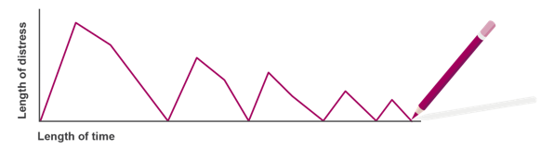

**How can we overcome avoidance?**

**Graded Exposure** is CBT-based technique based on evidence. It can help to overcome avoidance and safety behaviours by gradually facing your fears.

To use this technique properly, there are four **conditions**, or rules, that need to be followed.

**Graded:** Start with a small challenge and work your way up as you become more confident. You can do this by writing a list of feared situations and putting them in order of how anxious they make you feel.

**Repeated:** repeat the challenge a few more times to allow the process of habituation to happen. It usually takes about four attempts. You can monitor the anxiety reducing by keeping a diary of the times you challenge yourself.

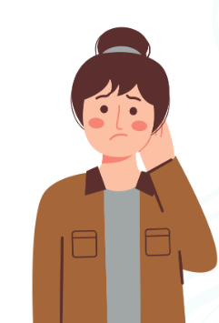

**Without distraction:** try and let the anxiety pass without doing anything to stop it artificially, such as avoidance or safety behaviours. If you notice a lot of safety behaviours, you may wish to reduce these gradually.

**Prolonged:** stay in the situation as long as you can, or until you can feel the anxiety and stress reducing by at least half. The amount of time this takes is different for each person.

**Task:** Choose something you avoid or safety behaviours to build a hierarchy to face your fears.

**Avoidance:**

|  |  |
| --- | --- |
| **Most Anxiety Provoking** | **Anxiety 100%** |
|  |  |
|  |  |
|  |  |
|  |  |
|  |  |
|  |  |
|  |  |
|  |  |
|  |  |
|  |  |
| **Least Anxiety Provoking** |  |

**Common choices that can impact our mood:**

When we feel anxious, it is normal to reach for the above things. They often give us short-term relief from anxiety. While everything is OK in moderation, sometimes making a habit of unhelpful things can make our mood worse in the long term.

**Task:**

Reflect on the ways your health behaviours have changed with anxiety. Do you do more or less of some things?



**Health Behaviour Change**

Here are some tips to help improve mood.

|  |  |  |  |  |  |  |  |  |  |  |
| --- | --- | --- | --- | --- | --- | --- | --- | --- | --- | --- |
| |  |  | | --- | --- | |  | Caffeine and anxiety share many physical symptoms (irritability, jitters and insomnia). Caffeine stays in your system for up six hours after consumption.  **Tip**: Try to avoid caffeine six hours before your usual bed time. | |  | Alcohol is a depressant. It slows down the brain’s production of “happy chemicals” such as serotonin. It affects our quality of sleep and impacts on our ability to cope with stress.  **Tip**: Try to reduce and have two alcohol free days each week. | |  | It is a common belief that smoking helps you relax. Instead, smoking actually increases feelings of anxiety and tension. Smoking stops the brain from producing dopamine, another “happy chemical”.  **Tip:** Speak to your GP if you’ would like help to stop smoking. | |  | Skipping meals or overeating can cause changes in our blood sugar. This can lead to feeling tired, irritable or depressed. There is a close link between our mental health and our gut health.  **Tip:** Try and eat three meals a day. Avoid foods that might cause a spike in blood sugars, such as those with high sugar and fat content. | |  | Regular exercise helps improve relaxation, muscle tension, sleep quality and appetite.  **Tip:** You do not have to go to the gym to exercise regularly. Try and find an enjoyable way to move your body regularly e.g. gardening, swimming or yoga. | |

**Why is sleep so important?**

Sleep helps us to process information from the day. It repairs our body and improves resilience. This all helps us to cope with daily stressors.

Tips for improving sleep:

* Avoid artificial light, particularly blue screens, before bed
* Try and relax by using relaxation exercises
* Make sure your environment is as comfortable as possible
* Make sure you have the right temperature
* Reduce distracting noises
* Avoid caffeine & alcohol
* Do not check the clock if you are awake
* Try and keep a regular bedtime / wake up time
* Having a balanced daytime routine can help you feel tired at bedtime

**Task:**

Think about the ways you would like to change your health behaviours. Make a plan and consider barriers.



**Between Session Tasks**

Each session, you will be set some tasks for the next week based on the information covered. It is important to practice each task regularly over the next week so you can begin to see some improvement in your anxiety.

**Session 4 tasks:**

* **Finish avoidance hierarchy and plan to start on exposure.**
* **Consider / plan a healthy lifestyle change.**

**End of session four review**

At the end of each session, reflect on what you've learned. Consider how you can apply it to your own situation. Use the prompt questions below to think about what you’re going to spend the next week practicing. Consider some solutions to any barriers that may prevent you making the agreed changes.

* **What did I learn in today’s session?**
* **How can I apply this to my own situation?**
* **What might get in the way of doing this?**
* **How can I stop this from happening?**
* **What am I going to practice from this session?**

**Session four - notes**

**Session**

**5th**

**Start of session five review**

It’s helpful to review the practice you have done over the last week. Don’t be disheartened if you haven’t been able to complete all the tasks. Instead, it is helpful to think about what got in the way and consider how to overcome this next time.

**How did you get on with the between-session tasks?**

**How do you feel about this?**

**Did you come across any barriers? How did/will you overcome them?**

**Moving forward after the course**

There is no right or wrong way to feel at this point in the course. You may be feeling better and ready to finish treatment. You may not be feeling better and wanting to explore further treatment options. You may be somewhere between.

It is helpful to think about how things have changed since the first session. This will help you plan for the future.

Consider how your thoughts, feelings and behaviours have changed by completing an updated five areas model.

**Completing your five areas**

Research tells us that it is common for problems like anxiety and depression to return. This is called lapsing and relapsing. While this may seem daunting, it is important to note that this is normal.

Feelings

Body

Situation

Behaviour

Thoughts

Mood

Mood

**Lapse**: A brief return in how we feel or what we do is normal. It is a temporary state and may be related to our current circumstances. ​

**Relapse**: A relapse happens when unhelpful thoughts or behaviours return over a longer period of time. Then, things begin to spiral.

It can be helpful to consider what thoughts, feelings or behaviours could be warning signs. They may show that you are feeling worse again. When you are more aware of them, they can be stopped quickly and more effectively.

Consider noticeable thought patterns, physical feelings, behaviours or situations that might trigger anxiety.

**Task: My Warning Signs**

|  |
| --- |
| **Situations**  **Thoughts**  **Physical feelings**  **Behaviours** |

**Wellbeing Action Plan**

As the course ends, it can be helpful to think about techniques you can continue using.

Think about the things you have changed over the past five weeks. Make a plan of what you will do in the future if needed.​

It is recommended to keep up all of the techniques you've learned. However, after a long period of feeling better, you may not need them. Sometimes they just become automatic e.g. thought challenging. Remembering what helps now can help you restart anything you stop doing in the future. ​

Consider setting a time to check back in with the wellbeing plan. This will help you identify if you are still following it or if any changes can be made. The length of time between check-ins is up to you. ​

Even if you aren’t feeling better, it is helpful to think about what has been helpful. As you move forward with treatment, consider what you’ll keep trying– no matter how small.

**Task: My Wellbeing Action Plan**

**What has been working well?**

**What helped last time?**

**What can I do now?**

**What can I continue doing?**

**Reviewing goals from Session one**

During session one, we discussed how setting a goal can improve motivation during treatment. Have a look back at the goal you set and think about how far you are from achieving it. You may have already done it, be part of the way there or not be close at all.

With this in mind, think about what you’d like to aim towards now the course is over. It could be the same as what you planned in the beginning or a slightly revised version. Tt could be something completely different.

​You may want to set a goal for further support or treatment. In these cases, it is helpful to use the 5 Areas Model to think about which specific areas need work.

**Task: My goals moving forward**

**Next Steps**

The next steps of treatment will depend on how you are currently feeling:

Based on the symptoms from your last questionnaire scores, you may be offered a review call. We will discuss alternative options for treatment. This will be offered a few weeks after the course has ended. If you are not offered a review call, you can contact our admin team to request it.

**End of session Review**

At the end of each session, reflect on what you've learned. Consider how you can apply it to your own situation. Use the prompt questions below to think about what you’re going to spend the next week practicing. Consider some solutions to any barriers that may prevent you making the agreed changes.

* **What did I learn in today’s session?**
* **How can I apply this to my own situation?**
* **What might get in the way of doing this?**
* **How can I stop this from happening?**
* **What am I going to practice from this session?**

**Session five notes**