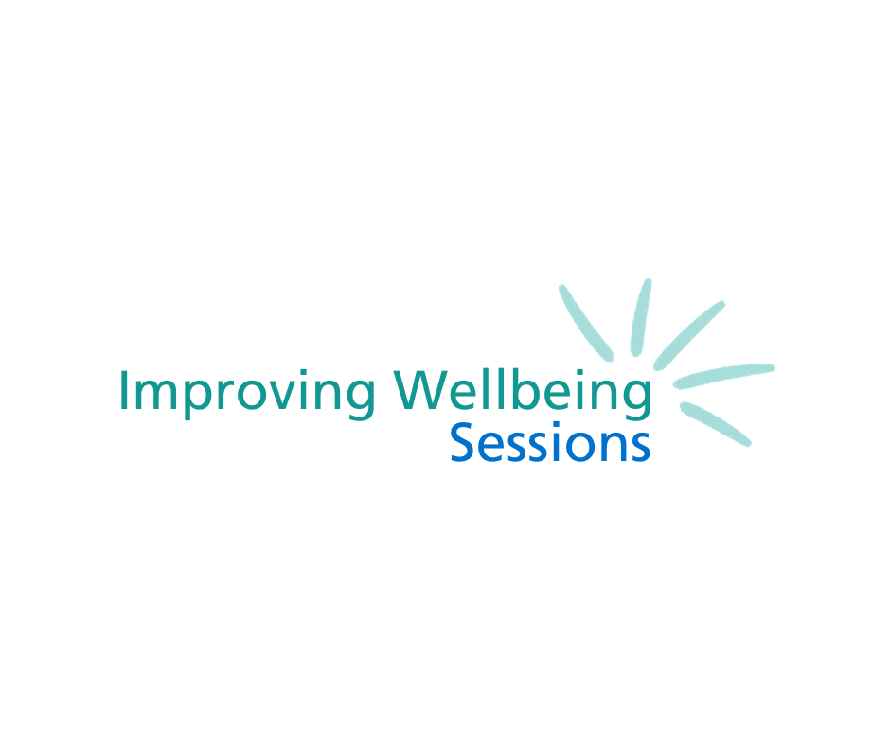

**Overcoming Low Mood**





**Contents**

|  |  |
| --- | --- |
| Helpful contacts to keep safe | 4 |
| Completing the questionnaires | 5 |
| **Session 1** |  |
| What is depression? | 7 |
| What are the signs of low mood? | 8 |
| The five areas model | 9-10 |
| Values | 11-12 |
| Goal setting | 13-14 |
| Between session task | 15 |
| End of session review | 16 |
| **Session 2** |  |
| Start of session review | 19 |
| What we do and how we feel | 20 |
| Behavioural Activation | 21 |
| Identifying unhelpful changes | 22 |
| Activity Diary | 23 |
| Activity List | 24 |
| Developing a hierarchy | 25-26 |
| Making a new plan | 27 |
| Planning ahead | 28-29 |
| Between session task | 30 |
| End of session review | 31 |
| **Session 3** |  |
| Start of session review | 34 |
| Unhelpful thinking | 35-36 |
| Cognitive Restructuring | 37 |
| Thought Diary | 38 |
| Challenging Thoughts | 39-42 |
| Rumination | 43 |
| Between session tasks | 44 |
| End of session review | 45 |
| **Session 4** |  |
| Start of session review | 48 |
| Common choices that impact our mood | 49 |
| Health Behaviour Change | 50 |
| Why is sleep important | 51 |
| Problem Solving | 52-55 |
| Between session tasks | 56 |
| End of session review | 57 |
| **Session 5** |  |
| Start of session review | 60 |
| Moving forward after the course | 61 |
| Five areas | 62-63 |
| Wellbeing action plan | 64-65 |
| Reviewing goals | 66 |
| Next steps | 67 |
| End of session review | 68 |

**Helpful contacts to keep safe**

**Need to contact Sheffield Talking Therapies?**

You can contact Talking Therapies Admin on **0114 226 4380.** Please let us know if you are unable to attend a session or you would like to discuss other treatment options.

**Need urgent help?**

If your mood is particularly low and you are concerned about your safety, please utilise the following information:

* Speak with friends and family for support
* If you can, make an appointment to **speak to your GP** as soon as possible
* **NHS 111 – select option for mental health support 123** (24 hours a day, 7 days a week)
* Samaritans: **116 123**
* Rethink: **0808 8010440**
* A blue silhouette of a head with a heart in the middle

  Description automatically generatedAlways call **999** in an emergency

**Completing the questionnaires**

Before each session we will send you questionnaires by email or text.

These questionnaires include the PHQ-9 which looks at symptoms of depression and the GAD-7 which looks at symptoms of anxiety.

These questionnaires can help measure the severity of your mood and it can show any changes in your mood during your treatment.

For each symptom, have a think about **how often** the symptom has bothered you over the last **two weeks** in total.

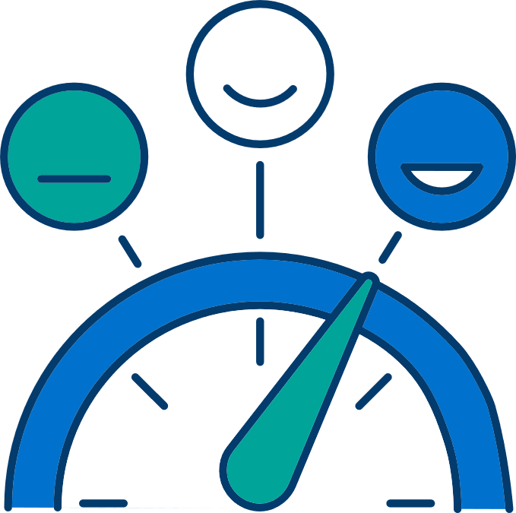

For each questionnaire, you can add up each number scored to provide you with a total score.

|  |  |  |  |  |  |
| --- | --- | --- | --- | --- | --- |
|  | **Session 1** | **Session 2** | **Session 3** | **Session 4** | **Session 5** |
| **PHQ-9**  **Depression** |  |  |  |  |  |
| **GAD-7**  **Anxiety** |  |  |  |  |  |

**The PHQ-9 is out of 27.   
The GAD-7 is out of 21.**

Add up your total each week to monitor your progress throughout the course.

**1st**

**Session**

**What is depression?**

Low mood is not just a biological or psychological illness. Low mood can be caused by stressful life events, physical reasons, difficulties with relationships and our early life experiences.

Low mood can affect everyone differently. It is common for low mood to affect our emotions, the way we feel in our bodies, the ways we think and the things we do.

**Task: What are the signs of low mood?**

**Feelings: Thinking:**

**Behaviours: Body:**

**The Five Areas Model**

Cognitive Behavioural Therapy (CBT) treatment focuses on the way our thoughts, feelings and behaviours interact with each other.

When feeling low, it is common to fall into a vicious cycle. Our thought processes and behaviour patterns can be unhelpful and keep low mood going. The more we think and behave in unhelpful ways, the longer the depression will last.

These vicious cycles can also be influenced by the way we interpret different situations. When we are feeling low, we are more likely to interpret situations negatively. This can lead to unhelpful feelings and behaviours.

When starting CBT, firstly identify your own unhelpful thought patterns and behaviours. This helps you formulate your own vicious cycle. Once you have identified your vicious cycle, you can learn how to break it and make changes.

Have a go at completing your own 5 areas model below.

Here is an example:

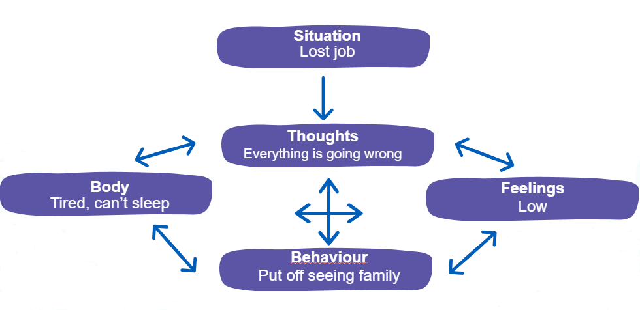

**Task**: Completing your five areas

Situation

Behaviour

Thoughts

Mood

Mood

Feelings

Body

**Values**

Before we start making changes to improve our mood, it is important to consider what things you value in your life. Also, consider how you might be living your life in relation to these.

**Values** represent the kind of person we want to be and the things we stand for in life. Thinking about values can identify what actions are important to us. We’re also more likely to achieve our goals when they are **valuable**.

There are many different values in life, but the most common values tend to be related to **relationships, spirituality, education, culture and our wellbeing.**

Using the task below, have a think about what actions are valuable to you.

**Task**: Complete your values compass



Friendships

Family/relationships

Religion

Other

Education/ career

Arts and culture

Physical wellbeing

Parenting/caring

**Goal setting**

Now you have an idea about what’s important to you and what you’d like to change, it can be helpful to set a goal to work towards. This increases motivation to complete the course of treatment. It also makes it more meaningful.

We can make goals more achievable by using the SMART goal structure. SMART is an acronym for the following:

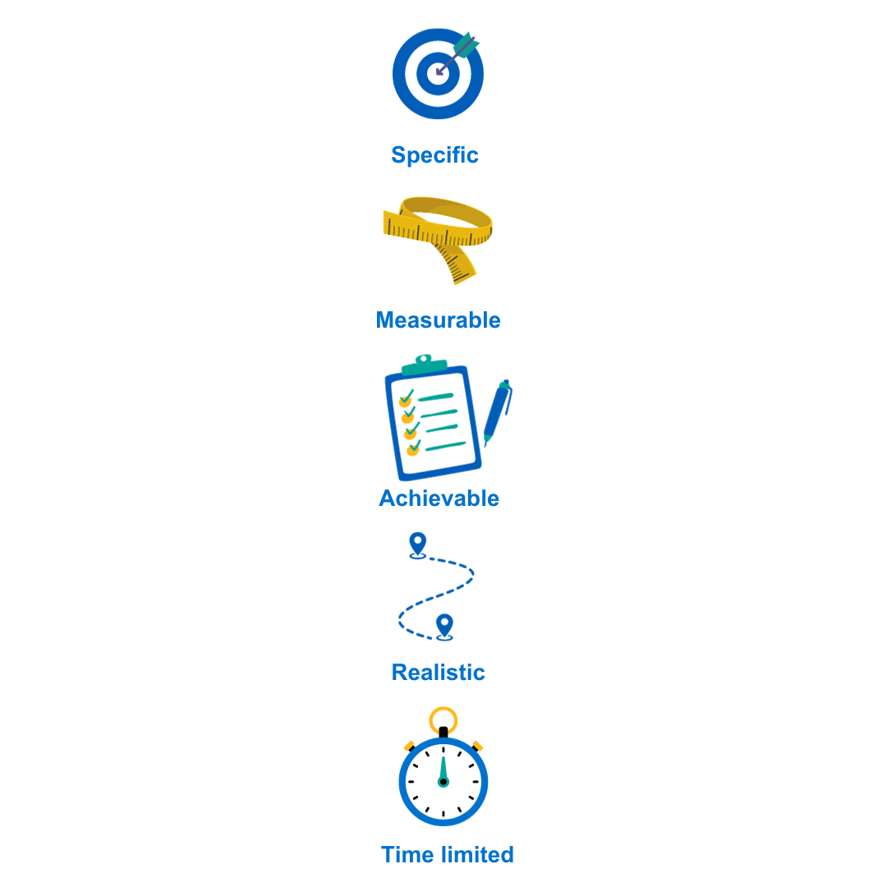

**What do I want to achieve?**

**How will I know I have reached the goal?**

**Can I achieve this goal with the resources I have?**

**Could anyone achieve this goal?**

**When should this goal be completed?**

Using the SMART Goal framework, have a go at setting your own goal for treatment. Have a think about what you’d like to be doing if you were feeling better.

It is important to consider **barriers** to achieving your goal. If there are some barriers, consider what you could put in place to solve them.

**Task**: Set a SMART Goal and consider barriers

**Between Session Tasks**

**My SMART goal:**

**What might get in the way:**

**How can I overcome this?**

Each session, you will be set some tasks for the next week based on the information covered. It is important to practice each task regularly over the next week. This will help you begin to see some improvement in your mood.

**Session one tasks:**

* **Finish creating your 5 areas model and problem statement**
* **Finish setting goals based on values**
* **Take the first step towards your goal**



**End of session 1 review**

At the end of each session, reflect on what you've learned. Consider how you can apply it to your own situation. Use the prompt questions below to think about what you’re going to spend the next week practicing. Consider some solutions to any barriers that may prevent you making the agreed changes.

* **What did I learn in today’s session?**
* **How can I apply this to my own situation?**
* **What might get in the way of doing this?**
* **How can I stop this from happening?**
* **What am I going to practice from this session?**

**Session one - notes**

**2nd**

**2nd**

**Session**

**Start of session two review**

It’s helpful to review the practice you have done over the last week. Don’t be disheartened if you haven’t been able to complete all the tasks. Instead, it is helpful to think about what got in the way and consider how to overcome this next time.

**How did you get on with the between-session tasks?**

**How do you feel about this?**

**Did you come across any barriers? How did/will you overcome them?**

**What we do and how we feel**

We know there is a direct link between what we do and how we feel. We feel better when we are busy, doing things, seeing other people, we have a role and a purpose. ​When we stop doing all of that, we get into a common cycle of inactivity.

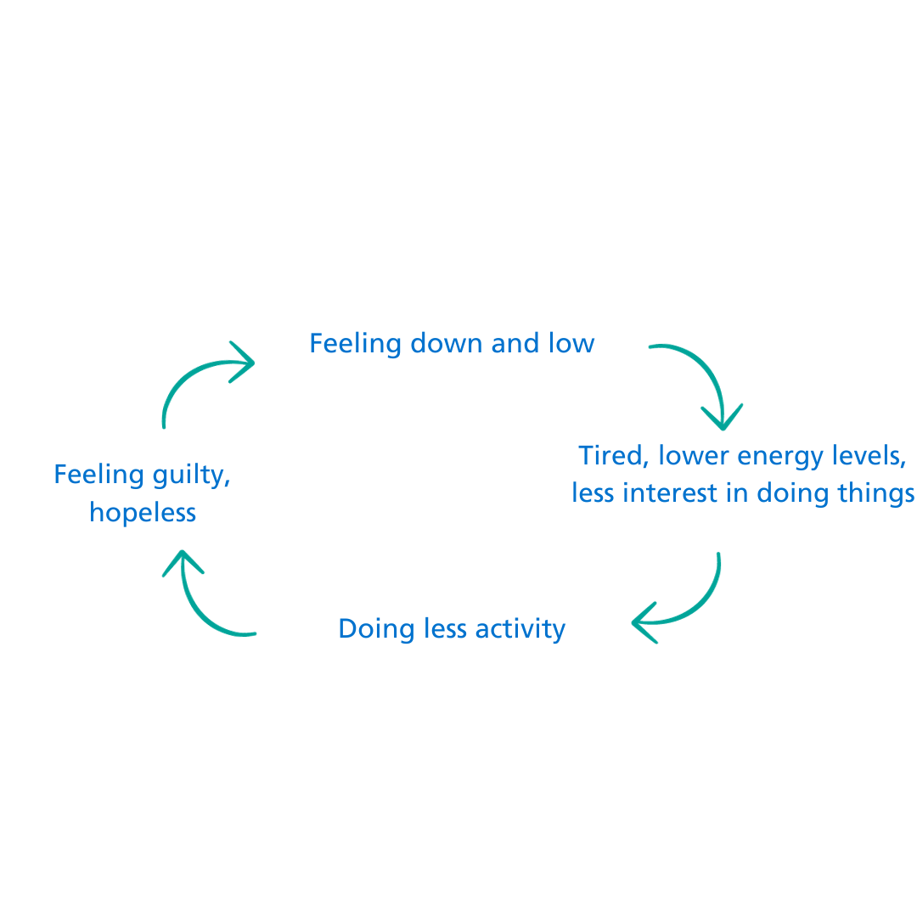

People experiencing low mood often want to do less and withdraw from the people around them. This is due to low motivation and tiredness. This may feel easier in the short term, but in the long term it keeps us feeling low. They won’t do things that are enjoyable, productive or connect them with others. This makes it more difficult to feel motivated and energised.

Making an effort to do meaningful activities even when motivation is low can reverse this cycle. When people challenge themselves to action, even when they don’t feel like it, they start to notice improvements in their mood. They feel more hopeful and motivated. This can increase motivation to do more.

**Behavioural activation**

Behavioural activation, or “BA” for short, is an evidence-based CBT based technique. It helps improve low mood. ​

Psychological research shows that people with a good routine of pleasurable, necessary and routine tasks are less likely to feel low. ​

Behavioural activation involves doing something even when you don't feel like it. Even doing something for a few minutes can create a sense of achievement and enjoyment. This can improve mood.

Doing this regularly will increase motivation. This will then increase positive feelings. This in turn develops a good routine. It keeps motivation and improved mood going throughout the week.

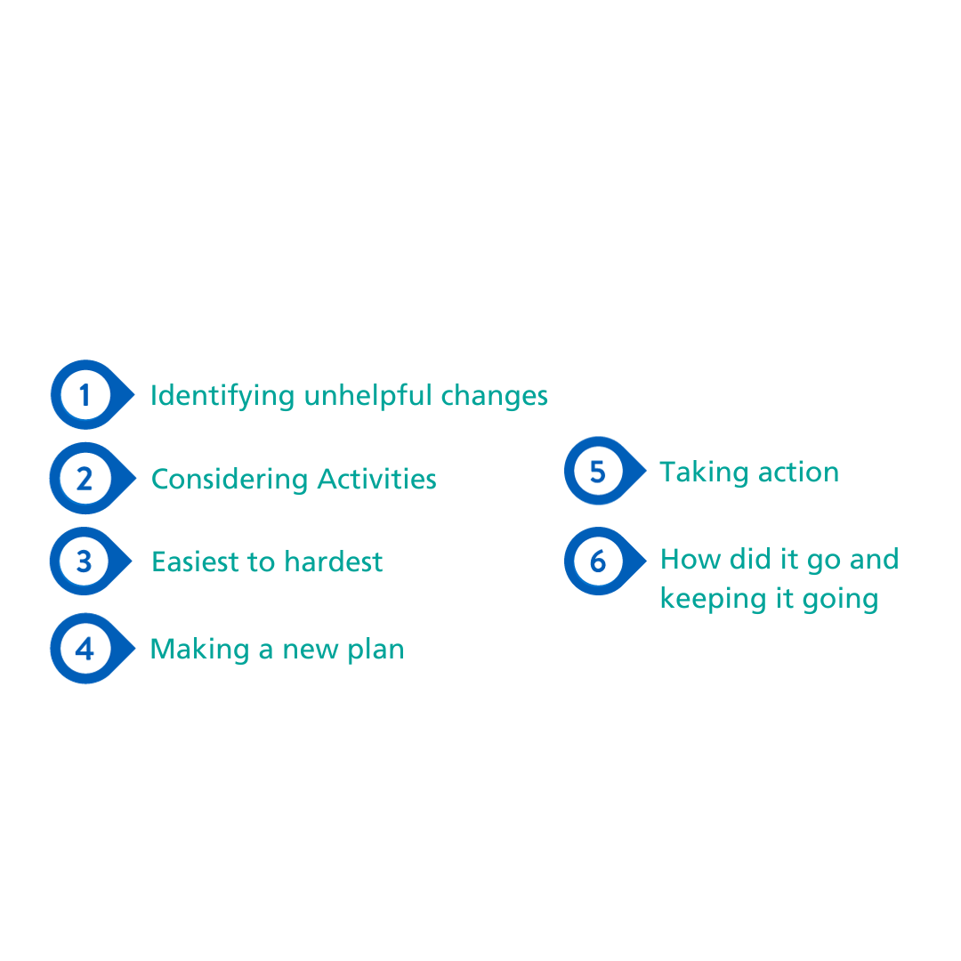Although it may sound simple, it can be difficult to put in to place when feeling low. Following the six steps below will make this easier.

Follow these steps to create a balanced routine. It will also increase opportunities to experience positive feelings.

**Step one:**

**Identifying unhelpful changes**

Firstly, it’s important to understand what things are like at the moment, while the low mood is happening.

Using the task below, consider how you’re spending your time at the moment. What is unhelpful? What have you stopped doing?

**Task: How has my behaviour changed?**

**What are you doing less of than you usually would?**

**What are you avoiding?**

**What activities/tasks boost your mood?**

**What activities/tasks bring your mood down?**

**Activity Diary**

|  |  |  |  |
| --- | --- | --- | --- |
|  | **Morning** | **Afternoon** | **Evening** |
| **Monday** |  |  |  |
| **Tuesday** |  |  |  |
| **Wednesday** |  |  |  |
| **Thursday** |  |  |  |
| **Friday** |  |  |  |
| **Saturday** |  |  |  |
| **Sunday** |  |  |  |

If you have not been able to answer the above questions, try and keep a diary of your activity over the next week or so. Have a think about how each action makes you feel: does it improve or bring down your mood?

**Step two:**

**Considering activities**

Step two involves making a list of the activities that you could be doing. You may have stopped these because of how you feel or maybe those that you are doing less of because of how you feel. It is helpful to split these activities into three categories, as seen below.

**Task:**

**Activities list**

Consider what activities you could be doing. Split them up into routine, necessary and pleasurable activities.

|  |
| --- |
| *Example: Laundry; Washing the pots* |
| *Example: Seeing friends; going to the cinema* |
| *Example: Dentist appointments; paying the bills* |

**Routine:** Activities that are done day to day to make our lives more comfortable.

**Pleasurable:** Activities that give a sense of achievement or connectedness to others. They improve our quality of life.

**Necessary:** Some activities are essential. The longer we leave them, the worse the negative consequences.

**Step three:**

**Developing a hierarchy**

Behavioural activation works best when changes are made gradually. Start with easier activities and progress to harder ones as your mood improves.

By doing this, the improvements you make become more sustainable.

Use the task below to order some activities from easiest to most difficult.

**Task:**

**Activities list: hierarchy**

|  |  |  |  |
| --- | --- | --- | --- |
|  | **Routine** | **Pleasurable** | **Necessary** |
| **Most difficult** |  |  |  |
| **Medium** |  |  |  |
| **Easiest** |  |  |  |

**Step four:**

**Making a new plan**

It is now important to start using the activities you’ve listed above to make a plan for the week ahead. Start with easy level activities only. Include a good balance of routine, necessary and pleasurable activities.

You do not have to account for every minute of your day. When you are starting out it’s important to include plenty of breaks to prevent exhaustion. A break is a time without scheduled activities.

You can use the SMART Goal framework to create specific tasks to complete during the week.

*e.g. Going for a walk in the park every morning at 09:00 after dropping the kids off at school.*

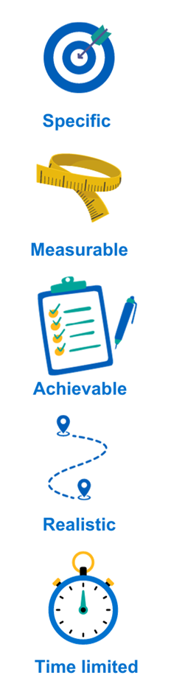

**Task: Planning ahead**

Have a go at planning some activities from the hierarchy over the next week.

|  |  |  |  |
| --- | --- | --- | --- |
|  | **Morning** | **Afternoon** | **Evening** |
| **Monday** |  |  |  |
| **Tuesday** |  |  |  |
| **Wednesday** |  |  |  |
| **Thursday** |  |  |  |
| **Friday** |  |  |  |
| **Saturday** |  |  |  |
| **Sunday** |  |  |  |

**Step five:**

**Taking action**

While you are doing your planned activities, notice how each makes you feel. Use the planner above to rate your feelings of enjoyment or achievement between 0-10.

Keep reflecting upon what is important and enjoyable to you. This will help you think about what activities you can continue doing in the future. It can also help you identify barriers to action and what you might do to overcome them.

**Step six:**

**Reviewing progress**

Reflect on how each week.

Keep setting new goals each time you reach one. It is important to keep challenging yourself.

If you didn’t do what you wanted, think about what stopped you. Consider doing things differently next time.

**The 5 Minute rule** can help when motivation is low. Challenging yourself to do a task for 5 minutes can jump start motivation. Often, once you have started something it can feel easier to finish it. If not, you can stop after five minutes. This still provides a small sense of achievement and is better than doing nothing.

**Between Session Tasks**

Each session, you will be set some tasks for the next week based on the information covered. It is important to practice each task regularly over the next week. This will help you begin to see some improvement in your mood.

**Session two tasks:**

* **Consider some SMART goals you would like to work towards**
* **Go forward and stick to your activity planner for the week**
* **Reflect on how the week goes, considering any barriers and possible solutions**

**End of session two review**

At the end of each session, reflect on what you've learned. Consider how you can apply it to your own situation. Use the prompt questions below to think about what you’re going to spend the next week practicing. Consider some solutions to any barriers that may prevent you making the agreed changes.

* **What did I learn in today’s session?**
* **How can I apply this to my own situation?**
* **What might get in the way of doing this?**
* **How can I stop this from happening?**
* **What am I going to practice from this session?**

**Session two - Notes**

**3rd**

**Session**

**Start of session three review**

It’s helpful to review the practice you have done over the last week. Don’t be disheartened if you haven’t been able to complete all the tasks. Instead, it is helpful to think about what got in the way and consider how to overcome this next time.

**How did you get on with the between-session tasks?**

**How do you feel about this?**

**Did you come across any barriers? How did/will you overcome them?**

**Unhelpful thinking**

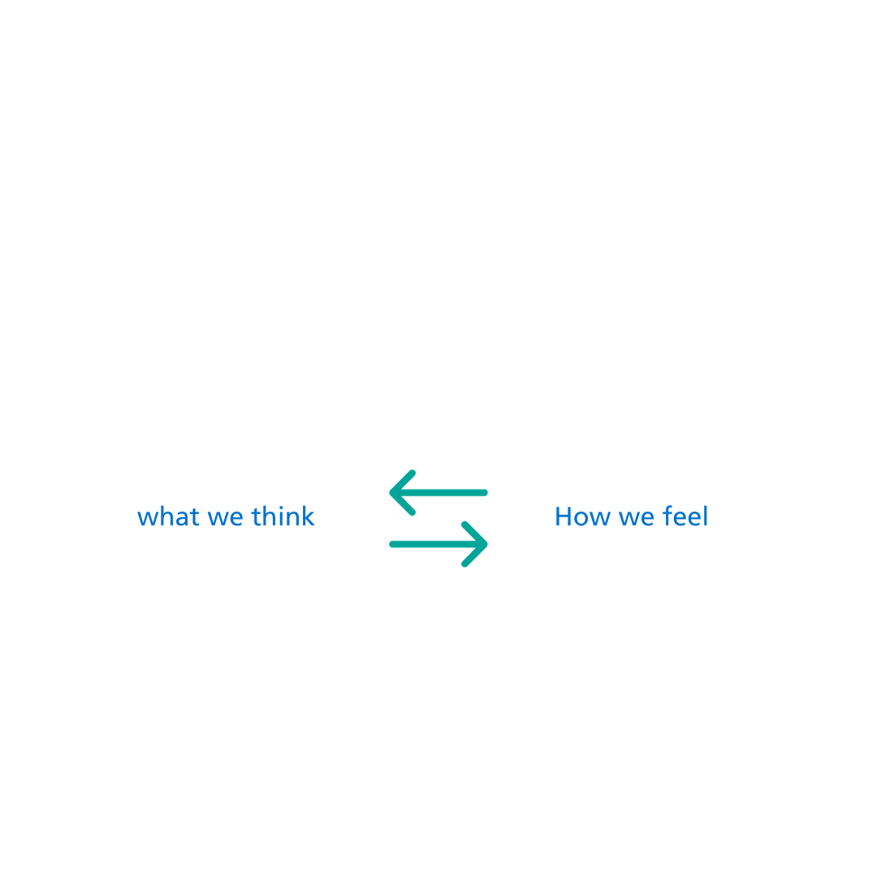

There is a close relationship between what we think and the way we feel.

On average, humans will have thousands of thoughts per day​. Even though they seem true at the time, thoughts are not facts and they can be true or untrue​.

The way we interpret things determines how we feel about it.

Not all thinking is careful and deliberate​ and many thoughts are automatic​. Automatic thoughts can be inaccurate due to unhelpful thinking styles​.

**Unhelpful Thinking Styles**

When we think in unhelpful ways, there tends to be common patterns. These patterns are known as unhelpful thinking styles.

|  |  |  |
| --- | --- | --- |
| **Name** | **Description** | **Example** |
| **All or Nothing** | Seeing things in extreme categories. | *If it is not perfect, then I have failed.* |
| **Should/Ought/Must** | Living life by unreasonable standards | *I should be getting up earlier.* |
| **Overgeneralising** | Seeing negative things as a never ending pattern of defeat. | *I’m never going to get another job.* |
| **Negative Mental Filter** | Seeing all situations through a negative lens. | *They gave lots of feedback but I only believe the negative* |
| **Catastrophising** | Imagining the worst case scenario. | *I fought with my partner but they’re going to leave me.* |
| **Mind Reading** | Assuming what others are thinking without knowing it. | *My friend is going to think I’m annoying.* |

Challenging unhelpful thoughts can help improve mood. This breaks the link between our automatic thoughts and feelings.

**Cognitive Restructuring**

Cognitive restructuring is an evidence-based technique. It can help change unhelpful beliefs by creating more balanced thoughts. When thoughts are more balanced, they are less distressing. ​

Cognitive restructuring is not about creating motivational quotes or thinking positively. It is about thinking in a more realistic way to reduce the connection between low mood and thoughts.

**Step 1: Catching Thoughts**

The first step of challenging unhelpful thoughts is to begin to notice unhelpful thinking​. This can help increase awareness of your thought processes. The more aware you are, the easier it will become to challenge.

Use the task below to keep a thought diary. Notice the emotion linked to the thought and its intensity.

Try and write down thoughts as soon as possible​ so you don’t forget.

**Task: Thought Diary**

|  |  |  |  |
| --- | --- | --- | --- |
| **Situation** | **Thought (% belief)** | **Emotion**  **(% intensity)** | **Unhelpful Thinking Style** |
|  |  |  |  |

**Step 2: Identifying Unhelpful Thinking**

Try and identify the **“hot thought”** from the thoughts you have collected. The “hot thought” is the part of the thought that gives you an instant negative reaction. For example, “I’m going to lose my job” or “my manager thinks I’m stupid”.

You can use the unhelpful thinking styles on page 36 to help you spot some automatic thoughts.

**Step 3: Challenging Unhelpful thinking**

Once you have identified some unhelpful thoughts, you can challenge them. Try to find evidence **for** and **against** the thought being true. This helps highlight that thoughts are not facts.

Imagine you are presenting your hot thought in a court room. You need to consider evidence that the thought is true and evidence the thought is false. Below are some questions you can ask yourself to help gather evidence:

Is this evidence fact or opinion?

Do I believe the thought 100% all of the time?

If I believe the thought 70%, what makes up the other 30% that doesn’t believe it?

How would I think about the situation if I wasn’t feeling this way?

What would I say to a friend in the same situation as me?

Are there any other ways that I could look at this situation?

Will this thought matter in five years’ time?

Is this way of thinking helping me to achieve my goals?

Is there something I can learn from this situation, to help me next time?

**Task: Challenging thoughts**

From your diary, choose a thought to challenge. Rate how much you believe the thought out of 100%. Then, try to find evidence that the thought is true and false.

|  |  |
| --- | --- |
| **My thought to challenge** | **Belief in thought %** |
| |  |  | | --- | --- | | **Evidence the thought is TRUE** | **Evidence the thought is FALSE** | |  |  | | |

**Step 4: Balancing thoughts**

You can now use the evidence you have gathered to create a **balanced thought** based in **fact.** Include as much evidence from the true and false column as you need to create a believable thought.

|  |
| --- |
| **My balanced thought** |
|  |

**Step 5: Reviewing Balanced Thoughts**

How does the new balanced thought compare with the old hot thought?

Use the table below. First rate your belief in the hot thought. Then rate your belief in the balanced thought that you created. Compare the difference, what do you see?

The aim of cognitive restructuring is not to completely erase your belief in the original thought. It's important not to expect this straight away. You may feel like you've failed and increase the unhelpful thoughts you are experiencing.​

The research about Cognitive Restructuring tells us that even a small shift in belief and distress is good enough. Hopefully, you’ll feel a slight improvement as a result. ​

The more you practice, the more confident you will feel with your thought challenging. This will reduce your belief and distress. ​

**Task: Reviewing thoughts**

|  |  |  |  |
| --- | --- | --- | --- |
| **Original Thought** | **My balanced thought** | **Belief Before %** | **Belief After %** |
|  |  |  |  |

**Cognitive Restructuring: A Summary**

* Writing thoughts down can be helpful
* Putting your thoughts on trial helps you find balanced alternatives
* Use the prompts in the thought diary to help find evidence against your hot thought
* Practice, practice, practice!

**Rumination**

**Rumination** is the concept ofrepeatedly going over negative experiences that have happened in the past. This may include painful thoughts and feelings. When you ruminate, you focus less on the world around you and more on the past​. This can distract us from the present and stops us from doing things that might make us feel better.

Using the ‘two minute rule’ can be helpful to make rumination more manageable.

**Two Minute Rumination Rule**

Once you notice that you are thinking about problems or past situations, continue for 2 minutes. Then, ask yourself:​

* Have I made any progress towards solving a problem?​
* Do I understand something about the problem that I have not understood before?​
* Do I feel less critical or less depressed than before I started thinking about this?​

If the answer to any of these questions is **no,** you are ruminating. Use this as a cue to action to do something different that will absorb your attention.

**Between Session Tasks**

Each session, you will be set some tasks for the next week based on the information covered. It is important to practice each task regularly over the next week so you can begin to see some improvement in your anxiety.

**Session three tasks:**

* **Try out the thought challenging process using a unhelpful thoughts you notice over the next week**
* **Notice ruminating and try out the rumination rule**

**End of session three Review**

At the end of each session, reflect on what you've learned. Consider how you can apply it to your own situation. Use the prompt questions below to think about what you’re going to spend the next week practicing. Consider some solutions to any barriers that may prevent you making the agreed changes.

* **What did I learn in today’s session?**
* **How can I apply this to my own situation?**
* **What might get in the way of doing this?**
* **How can I stop this from happening?**
* **What am I going to practice from this session?**

**Session three – notes**

**4th**

**Session**

**Start of session four review**

It’s helpful to review the practice you have done over the last week. Don’t be disheartened if you haven’t been able to complete all the tasks. Instead, it is helpful to think about what got in the way and consider how to overcome this next time.

**How did you get on with the between-session tasks?**

**How do you feel about this?**

**Did you come across any barriers? How did/will you overcome them?**

**Common choices that can impact our mood:**

When we feel low, it is normal to reach for the above things. They often give us short-term relief from low mood. While everything is OK in moderation, sometimes making a habit of unhelpful things can make our mood worse in the long term.

**Task:**

Reflect on the ways your health behaviours have changed with low mood. Do you do more or less of some things?

**Health Behaviour Change**

Here are some tips to help improve mood.

|  |  |  |  |  |  |  |  |  |  |  |
| --- | --- | --- | --- | --- | --- | --- | --- | --- | --- | --- |
| |  |  | | --- | --- | |  | Caffeine and anxiety share many physical symptoms (irritability, jitters and insomnia). Caffeine stays in your system for up six hours after consumption.  **Tip**: Try to avoid caffeine six hours before your usual bed time. | |  | Alcohol is a depressant. It slows down the brain’s production of “happy chemicals” such as serotonin. It affects our quality of sleep and impacts on our ability to cope with stress.  **Tip**: Try to reduce and have two alcohol free days each week. | |  | It is a common belief that smoking helps you relax. Instead, smoking actually increases feelings of anxiety and tension. Smoking stops the brain from producing dopamine, another “happy chemical”.  **Tip:** Speak to your GP if you’ would like help to stop smoking. | |  | Skipping meals or overeating can cause changes in our blood sugar. This can lead to feeling tired, irritable or depressed. There is a close link between our mental health and our gut health.  **Tip:** Try and eat three meals a day. Avoid foods that might cause a spike in blood sugars, such as those with high sugar and fat content. | |  | Regular exercise helps improve relaxation, muscle tension, sleep quality and appetite.  **Tip:** You do not have to go to the gym to exercise regularly. Try and find an enjoyable way to move your body regularly e.g. gardening, swimming or yoga. | |

**Why is sleep so important?**

Sleep helps us to process information from the day. It repairs our body and improves resilience. This all helps us to cope with daily stressors.

**Tips for improving sleep:**

* Avoid artificial light, particularly blue screens, before bed
* Try and relax by using relaxation exercises
* Make sure your environment is as comfortable as possible
* Make sure you have the right temperature
* Reduce distracting noises
* Avoid caffeine & alcohol
* Do not check the clock if you are awake
* Try and keep a regular bedtime / wake up time
* Having a balanced daytime routine can help you feel tired at bedtime

**Task:**

Think about the ways you would like to change your health behaviours. Make a plan and consider barriers.



**Problem solving**

Depression may have a negative impact on our natural problem-solving ability. It can be difficult to think of solutions to practical issues and find the motivation to carry out the solutions.

Problem solving is a simple, structured technique to work towards solving a practical problem.

This tool can help you to solve a problem when you feel overwhelmed and can’t find a solution. For example, problem solving could be used if you have overdue bills, a problem at work or if something at home is broken and needs repairing.

Use the steps below to solve a problem you are struggling to solve at the moment.

**Step 1: Identify the Problem**

**Step 2: Identify all the possible solutions**

**Step 3: Analyse strengths and weaknesses**

|  |  |  |
| --- | --- | --- |
| **Solution** | **Strengths** | **Weaknesses** |
| *Example: Getting a second job to contribute to overdue bills* | *More money to put towards energy bills* | *Increased stress and tiredness*  *Will need to organise more childcare* |
|  |  |  |
|  |  |  |
|  |  |  |

**Step 4: Pick the best solution**

**Step 5: Make a plan – be specific. When, who, where, how?**

**Step 6: Carry out the plan**

**Step 7: Review, how did it go? What could you do differently?**

**Between Session Tasks**

Each session, you will be set some tasks for the next week based on the information covered. It is important to practice each task regularly over the next week so you can begin to see some improvement in your anxiety.

**Session 4 tasks:**

* **Consider what changes can be made regarding your health. Set SMART goals to achieve them.**
* **Use the problem-solving technique to identify solutions for current difficulties**

**End of session four Review**

At the end of each session, reflect on what you've learned. Consider how you can apply it to your own situation. Use the prompt questions below to think about what you’re going to spend the next week practicing. Consider some solutions to any barriers that may prevent you making the agreed changes.

* **What did I learn in today’s session?**
* **How can I apply this to my own situation?**
* **What might get in the way of doing this?**
* **How can I stop this from happening?**
* **What am I going to practice from this session?**

**Session four - notes**

**5th**

**Session**

**Start of session five review**

It’s helpful to review the practice you have done over the last week. Don’t be disheartened if you haven’t been able to complete all the tasks. Instead, it is helpful to think about what got in the way and consider how to overcome this next time.

**How did you get on with the between-session tasks?**

**How do you feel about this?**

**Did you come across any barriers? How did/will you overcome them?**

**Moving forward after the course**

There is no right or wrong way to feel at this point in the course. You may be feeling better and ready to finish treatment. You may not be feeling better and wanting to explore further treatment options. You may be somewhere between.

It is helpful to think about how things have changed since the first session. This will help you plan for the future.

Consider how your thoughts, feelings and behaviours have changed by completing an updated five areas model.

Mood

**Completing your five areas**

Feelings

Body

Situation

Behaviour

Thoughts

Research tells us that it is common for problems like anxiety and depression to return. This is called lapsing and relapsing. While this may seem daunting, it is important to note that this is normal.

**Lapse**: A brief return in how we feel or what we do is normal. It is a temporary state and may be related to our current circumstances. ​

**Relapse**: A relapse happens when unhelpful thoughts or behaviours return over a longer period of time. Then, things begin to spiral.

It can be helpful to consider what thoughts, feelings or behaviours could be warning signs. They may show that you are feeling worse again. When you are more aware of them, they can be stopped quickly and more effectively.

Consider noticeable thought patterns, physical feelings, behaviours or situations that might trigger anxiety.

**Task: My Warning Signs**

|  |
| --- |
| **Situations**  **Thoughts**  **Physical feelings**  **Behaviours** |

**Wellbeing Action Plan**

As the course ends, it can be helpful to think about techniques you can continue using.

Think about the things you have changed over the past five weeks. Make a plan of what you will do in the future if needed.​

It is recommended to keep up all of the techniques you've learned. However, after a long period of feeling better, you may not need them. Sometimes they just become automatic e.g. thought challenging. Remembering what helps now can help you restart anything you stop doing in the future. ​

Consider setting a time to check back in with the wellbeing plan. This will help you identify if you are still following it or if any changes can be made. The length of time between check-ins is up to you. ​

Even if you aren’t feeling better, it is helpful to think about what has been helpful. As you move forward with treatment, consider what you’ll keep trying– no matter how small.

**Task: My Wellbeing Action Plan**

**What has been working well?**

**What helped last time?**

**What can I do now?**

**What can I continue doing?**

**Reviewing goals from Session one**

During session one, we discussed how setting a goal can improve motivation during treatment. Have a look back at the goal you set and think about how far you are from achieving it. You may have already done it, be part of the way there or not be close at all.

With this in mind, think about what you’d like to aim towards now the course is over. It could be the same as what you planned in the beginning or a slightly revised version. Tt could be something completely different.

​You may want to set a goal for further support or treatment. In these cases, it is helpful to use the 5 Areas Model to think about which specific areas need work.

**Task: My goals moving forward**

|  |
| --- |
|  |

**Next Steps**

The next steps of treatment will depend on how you are currently feeling:

Based on the symptoms from your last questionnaire scores, you may be offered a review call. We will discuss alternative options for treatment. This will be offered a few weeks after the course has ended. If you are not offered a review call, you can contact our admin team to request it.

**End of session Review**

At the end of each session, it is important to reflect on what you have learned and how you can apply it to your own situation. Use the prompt questions below to think about what you’re going to spend the next week practicing. Consider some solutions to any obstacles that may prevent you making the agreed changes.

* **What did I learn in today’s session?**
* **How can I apply this to my own situation?**
* **What might get in the way of doing this?**
* **How can I stop this from happening?**
* **What am I going to practice from this session?**

**Session five notes**