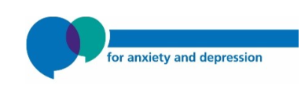



**Living Well with a Long-Term Condition and Low Mood**



**Contents**

|  |  |
| --- | --- |
| Helpful contacts to keep safe | 4 |
| Completing the questionnaires | 5 |
| **Session 1** |  |
| What is a long-term condition? | 8 |
| The impact of living with a long-term condition | 9 |
| Short-term vs long-term conditions | 10 |
| The bio-psycho-social model | 11-12 |
| Toolbox | 13 |
| What does acceptance mean | 14 |
| Signs of low mood | 15 |
| The five areas model | 16-17 |
| Between session tasks | 18 |
| End of session review | 19 |
| **Session 2** |  |
| Start of session review | 22 |
| Long term conditions and activity | 23 |
| Sadness and low mood | 24 |
| Managing low mood  Values | 25-26  27-28 |
| Planning realistic activities | 29 |
| Goal setting | 30-31 |
| Between session tasks | 32 |
| End of session review | 33 |
| **Session 3** |  |
| Start of session review | 36 |
| Boom and bust cycle | 37-38 |
| Take it easy trap | 39 |
| Pacing, planning and prioritising | 40-43 |
| Planning ahead using pacing | 44 |
| Functional equivalence | 45-46 |
| Between session tasks | 47 |
| End of session review | 48 |
| **Session 4** |  |
| Start of session review | 51 |
| When thoughts become unhelpful | 52 |
| Unhelpful thinking styles | 53 |
| Cognitive Restructuring | 54-60 |
| Rumination and the two-minute rule | 61 |
| Being kind to yourself | 62 |
| The stages of sleep | 63-64 |
| Tips to improve sleep | 65-69 |
| Between Session Tasks | 69 |
| End of session review | 70 |
| **Session 5** |  |
| Start of session review | 74 |
| Self-management | 75 |
| Gathering information about your LTC | 76 |
| Managing medication | 78 |
| Communication styles and assertiveness | 80-86 |
| Scripting | 87 |
| Mindfulness  Moving forward after the course | 88  89 |

**Helpful contacts to keep safe**

**Need to contact Sheffield Talking Therapies?**

You can contact Talking Therapies Admin on **0114 226 4380. Please let us know if you are unable to attend a session or you would like to discuss other treatment options.**

**Need urgent help?**

If your mood is particularly low and you are concerned about your safety, please use the following information:

* Speak with friends and family for support.
* Please make an appointment to **speak to your GP** as soon as possible.
* If you cannot reach your GP or are calling out of hours, you can call **NHS 111**
* Samaritans: **116 123**
* Rethink: **0808 8010440**
* Sheffield Health and Social Care 24hr Helpline: **0114 2263636** or **0808 196 8281**
* A blue silhouette of a head with a heart in the middle

  Description automatically generatedAlways call **999** in an emergency

**Completing the questionnaires**

Before each session we will send you questionnaires by email or text.

These questionnaires include the PHQ-9 which looks at symptoms of depression and the GAD-7 which looks at symptoms of anxiety.

These questionnaires can help measure the severity of your mood and it can show any changes in your mood during your treatment.

For each symptom, have a think about **how often** the symptom has bothered you over the last **two weeks** in total.

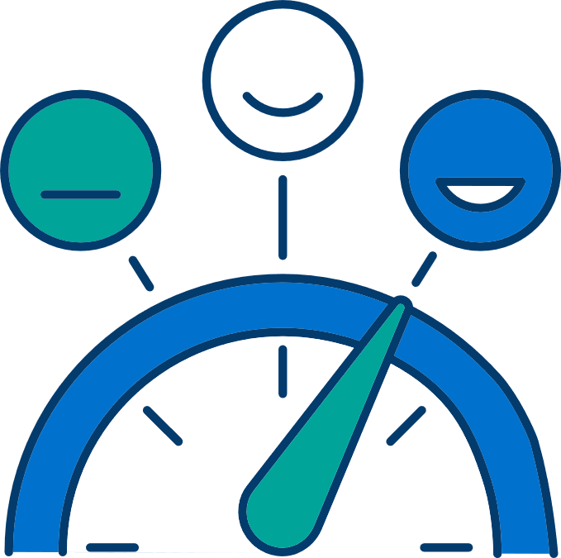

|  |
| --- |
|  |

For each questionnaire, you can add up each number scored to provide you with a total score.

**The PHQ-9 is out of 27.   
The GAD-7 is out of 21.**

|  |  |  |  |  |  |
| --- | --- | --- | --- | --- | --- |
|  | **Session 1** | **Session 2** | **Session 3** | **Session 4** | **Session 5** |
| **PHQ-9**  Depression |  |  |  |  |  |
| **GAD-7**  Anxiety |  |  |  |  |  |

Add up your total each week to watch your progress throughout the course.

**Living well with a long-term condition (LTC) course**

Welcome to the living well with a long-term condition low mood course. This course is provided by Sheffield Talking Therapies, an NHS service that offers treatment for depression and anxiety. This course is made up of five sessions which take place on the same day, at the same time for five weeks. We recommend that you should attend all five sessions; the information is designed to fit together like a jigsaw. There will be a short break during each session.

We recognise that when someone has a long-term condition, they are more likely to experience difficulties with their mental health such as lacking motivation, not wanting spend time with friends and family and can often start to feel fed up. On this course we try to give you a way to make sense of what you feel like while you live with a long-term condition. We will share information and ideas that you can practice at home that might have a positive effect on how you feel.

Please have this workbook with you to every session of the course, you can write notes in it, and you will find worksheets that will help you to use some of these ideas at home. You are welcome to copy these worksheets or design your own. If you share pages from the workbook with other people, please explain where the pages came from.

If you have got any questions about The Living Well with Long-term Conditions Course or the Talking Therapies service then please speak to the course facilitators, or look on our website at www.sheffieldtalkingtherapies.shsc.nhs.uk

**Session**

**1st**

**What is a long-term condition (LTC)?**

Long-term conditions can be defined as physical health problems that cannot, at present, be cured but can be controlled and managed by medication and other therapies. They are very common, and it is estimated that over 15 million people in England and Wales have one or more diagnoses and the number is growing.

There are many different types of disease that are termed as long-term conditions. Some long-term conditions have a clear underlying disease process that causes them (e.g. Asthma, Arthritis, Diabetes etc). Some other long-term conditions may not have a clear disease process underlying them (e.g. Fibromyalgia, Irritable Bowel Syndrome, Chronic Pain). Nevertheless, all long-term conditions have much in common in terms of being characterised by ongoing persistent symptoms. How you learn to live and manage them is important to wellbeing.

**What has changed in your life because of your long-term condition?**

**The impact of living with a long-term condition**

It’s important to note that living with a long-term condition can have a huge impact on many different aspects of your life. It may limit your physical functioning and/or energy levels. Perhaps your condition brings with it discomfort or pain. All of these experiences associated with having a long-term condition can have an impact on many different areas of life:

* Ability to work
* Activities, satisfaction and enjoyment
* Relationships with family and friends
* Self confidence
* Identity as an individual e.g. ‘I’m not the person I used to be’ or ‘I’m a burden to others’
* Sleeping patterns
* Feeling like all your time is pre-occupied with health concerns
* Uncertainty about the future
* Concentration problems
* Mood e.g. stress, worry, anxiety, frustration/irritability, sadness, low mood and anger

**Differences between short-term (Acute) health problems and long-term (Chronic) health problems**

Some key differences between acute health problems and long-term conditions are presented in table 1 below:

**Table 1:**

|  |  |  |
| --- | --- | --- |
| **Features** | **Short-Term Condition** | **Long-Term Condition** |
| Diagnosis | Often immediate and accurate | Mixed |
| Aim of treatment | Cure | Managing condition |
| Duration | Short term (often less than 6 months) | Longer term, sometimes lifelong |
| Role of professional | Diagnosis, Treatment | Diagnosis, Treatment Education, Disease management |
| Role of patient | Adhere to treatment | Responsible for day-to-day management of illness  Maintaining relationships with  Health Care Professionals |

**A broader view of living with a long-term condition**

**A bio-psycho-social perspective**

One way to begin to think about your experience of living with a long-term condition might be for you to begin to view your long-term condition in the broadest possible way, looking at all the different aspects of living with a long-term condition. We call this view, a ‘bio-psycho-social’ perspective. This model sounds a bit complicated but it’s actually quite a common sense approach. It takes into account all the factors that can cause a person to feel unwell & groups them for convenience’s sake into three areas: biological, psychological and social.

**A representation of the bio-psycho-social model**

**Biological factors** are to do with the illness itself. It also includes physical factors e.g. fatigue and pain. This area also refers to investigations, diagnosis, medical and physical treatments.

**Psychological factors** are about how you think, feel and what you do in relation to living with a long-term condition. E.g. It’s very common for people living with a long-term condition to worry and/or focus on symptoms which might make you feel on edge or stressed. Feeling stressed is often the result of feeling overwhelmed and this may result in you feeling less confident or less able to look after yourself.

**Social factors** are about how we relate to others including family and friends as well as health care professionals. It includes the way we communicate and interact with others and how well supported we feel.

It may be you can see that these different factors influence and overlap with each other e.g. Not seeing your friends or family might make your mood low which may in turn make you feel tired and result in you sitting alone on the settee and not attending your appointment that afternoon.

Understanding these factors can help you highlight or identify areas of concern of living with your illness which might be the first step in helping you form some ideas about how to tackle these concerns.

**Task 1: Your toolbox**

It can be helpful to think about having a box of tools that you can choose to help you deal with your long-term condition. Medication is just one of your tools, but this doesn’t work for all of the problems. We need additional tools in the box to help.

**Use the space below to think about how you already cope with the effect of your illness. Write down any tools or ideas that you see on the slides that you would like to know more or to try.**

**What does acceptance mean? The box and ball**

Living with pain, illness, suffering, or difficulty is hard work. Sometimes the way that we think about and react to what is happening in our life can affect how bad it feels.

You can choose to notice the hard things in your life. If you do, you can see the problem without wanting to get rid of it or resisting it. This might give you more time, attention, and energy for other things. Instead of shrinking the ball, you might be able to make the box bigger.

**What are some of the signs of low mood that you have noticed?**

**Thoughts**

e.g. what if I can’t get to work today, everyone thinks I’m useless

**Feelings**

e.g. nervous, worried, low

**Body**

e.g. aching, headaches

**Behaviours**

e.g. staying in bed, not wanting to see anyone.

**The Five Areas Model**

Cognitive Behavioural Therapy (CBT) treatment focuses on the way our thoughts, feelings and behaviours link with each other.

When feeling low, it is common to fall into a vicious cycle. In this vicious cycle, our thought processes and behaviour patterns can be unhelpful. They keep low mood going. The more we think and behave in unhelpful ways, the longer the low mood will last.

These vicious cycles can also be influenced by the way we interpret different situations. When we feel low, we tend to interpret situations negatively. This can lead to unhelpful feelings and behaviours.

When starting CBT, it is helpful to identify your own unhelpful thought patterns and behaviours. This helps you find your vicious cycle. Once you have identified your vicious cycle, you can learn how to break it and make changes.

Here is an example:

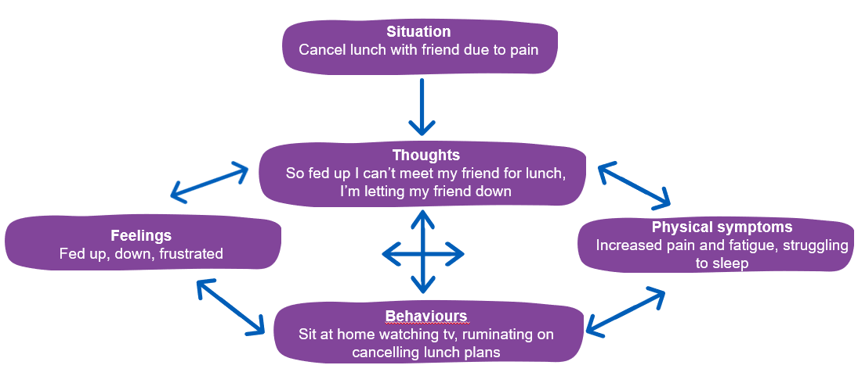

**Task 2: Completing your five areas**

Situation

Thoughts

Body

Behaviour

Feelings

**Between Session Tasks**

Each session, you will set some tasks for the next week based on the material covered. It is important to practice each task regularly over the next week to begin to see improvement in your mood.

**Session 1 Between Session Tasks:**

**1. Consider what tools you are already using to help cope with your LTC**

**2. Finish your 5 areas model for a recent situation where you felt low because of your LTC**



**End of session 1 review**

At the end of each session, reflect on what you've learned. Consider how you can apply it to your own situation. Use the prompt questions below to think about what you’re going to spend the next week practicing. Consider some solutions to any barriers that may prevent you making the agreed changes.

* **What did I learn in today’s session?**
* **How can I apply this to my own situation?**
* **What might get in the way of doing this?**
* **How can I stop this from happening?**
* **What am I going to practice from this session?**

**Session 1 - notes**

**2nd**

**Session**

**Start of session 2 review**

It’s helpful to review the practice you have done over the last week. Don’t be disheartened if you haven’t been able to complete all the tasks. Instead, it is helpful to think about what got in the way and consider how to overcome this next time.

**How did you get on with the between-session tasks?**

**How do you feel about this?**

**Did you come across any barriers? How did/will you overcome them?**

**Long-term conditions and activity**

**The emotional impact of living with a long-term condition**

Emotions are part of an experience that we describe in one word: happy, sad, angry, guilty, shame and fear.

Our beliefs, thoughts, physical changes and behaviour can all impact on how we feel emotionally (think about the Five Areas Model). In Cognitive Behavioural Therapy (CBT), we think that all emotions can be helpful to some degree, but sometimes an emotion can feel overwhelming and get in the way of looking after yourself and living life to the best of your ability.

**We can think of emotions as having three parts:**

1. The **emotion** is described in one word
2. Changes may occur in your **body** in response to the emotion/mood
3. **Behaviour** (what you do or don’t do) is a result of the emotion that you feel

**Normal emotions**

* Sadness/low mood
* Happiness/contentment
* Fear
* Anxiety and worry
* Anger
* Guilt

**Sadness and low mood**

**Helpful because:** Sadness can be unpleasant, but it helps us to adjust to loss. You might lose someone or something that is important to you like your health and the ability to do things you enjoy.

* Prompts you to have the time to come to accept the loss
* Prompts you to grieve and make sense of what has happened or changed
* Signals to others that you need space and consideration

It can make you **physically** tired and tearful and make you want to withdraw from other people, do less activity overall and cry.

**With a long-term condition:** it is normal to feel sad about how life has changed. You might not be able to work, do things that you enjoy, or socialise the way you could before. You might feel like you are not the person you used to be.

Coming to terms with all of this is not a straightforward process. Sadness might come and go but this is normal.

**Less helpful when:** It is important not to over-use sadness. In deliberately dwelling on thoughts of loss it is not acknowledging them or coming to terms with them.

If you feel stuck in sadness you might find it helpful to talk to a counsellor.

Emotions can use up a lot of energy.

**Happiness/Contentment**

Happiness is a rewarding feeling. A sense that life is worthwhile and that what you do matters and means something. It can help motivate you to do routine, necessary and pleasurable tasks. It is often associated with feeling physically lighter, eating healthily, having more energy, sleeping well and having good relationships.

With adjustments, happiness/contentment can still be achievable even with a long-term condition.

**Managing Low Mood**

Persistent low mood, or depression, is a natural reaction to difficult life events. You might be more likely to feel this way if you feel that you have lost something because you live with pain in your life. However it starts, your behaviour can have a big effect on how quickly depression gets better.

When people are low in mood, they are often tired and lose interested in things that they usually enjoy. Many people with low mood are bothered by negative thoughts about themselves and the world. All of this can lead to a pattern of avoiding and putting off doing things. This can keep depression going. A diagram of a diagram

Imagine that you have been feeling low for a while and a friend rings you to invite you out. The thought of getting ready and going out might make you feel tired. You might think that they don’t really want to see you, or worry that you haven’t got anything interesting to say.

These predictions will make you feel uncomfortable so you decide to tell your friend that you can’t see them. As soon as you get out of going you feel better – you feel relief from the horrible feelings.

Unfortunately doing this means that you have fewer opportunities to feel enjoyment or a sense of achievement. When the relief fades you might

be left feeling guilty or upset with yourself, and disappointed, which would make your low mood worse.

**Using Behaviour to Manage Low Mood**

If low mood is affecting you then one of the most effective ways to manage this is to change how you use your time. Many people with low mood don’t feel motivated to do things that would give them an opportunity to feel differently. Instead of waiting to feel motivated we suggest trying to do some things anyway. You can use the activity diary to plan what you will do. Sometimes seeing things written down can help you to do them.

There are three kinds of activity that it can be helpful to look at:

**Necessary activities** – are the things that you need to do or there will be unwanted consequences. E.g. paying the rent, getting your children to school. These might be the first things that you want to plan into your diary.

**Routine activities** – are the things that you do to feel comfortable in your body and environment. E.g. brushing your teeth and washing yourself, cleaning your house, eating meals. Some of these activities are very short and easy and can help you to feel more comfortable very quickly.

**Pleasure and achievement** – are the things that give you opportunities to have fun or feel like you’ve done something really worthwhile. You might not feel how you expect to feel when you do these at first but if you can keep doing them, they’re likely to have an effect on your mood.

When you are planning your activities it can be helpful to prioritise the things that matter the most to you.

**Values**

Before you can start to improve your mood, you need to consider what you value in your life. Also, how you might be living in relation to these values.

**Values** represent the kind of person we want to be and the things we stand for in life. Thinking about values can identify what actions are important to us. We’re also more likely to achieve our goals when they are **valuable**.

**Try Task 3 on the following page and then consider the following questions:**

1. **Which of the values are the most important to you?**
2. **Describe your values in that area**
3. **What activities do you currently do that meet that value?**

**Task 3**: Complete your values compass****

Friendships

Family/relationships

Religion

Other

Education/ career

Arts and culture

Physical wellbeing

Parenting/caring

**Task 4: Planning realistic activities**

**Considering your values, start to identify whether these fall into any of the below categories. Below you can rank them from easiest to most difficult – remember we need to start with those that feel achievable.**

|  |  |  |  |
| --- | --- | --- | --- |
|  | **Routine** | **Pleasurable** | **Necessary** |
| **Most difficult** |  |  |  |
| **Medium** |  |  |  |
| **Easiest** |  |  |  |

**Goal setting**

Now you have an idea about what’s important to you and what you’d like to change, it can be helpful to set a goal to work towards. This increases motivation to complete the course of treatment. It also makes it more meaningful.

We can make goals more achievable by using the SMART goal structure. SMART is an acronym for the following:

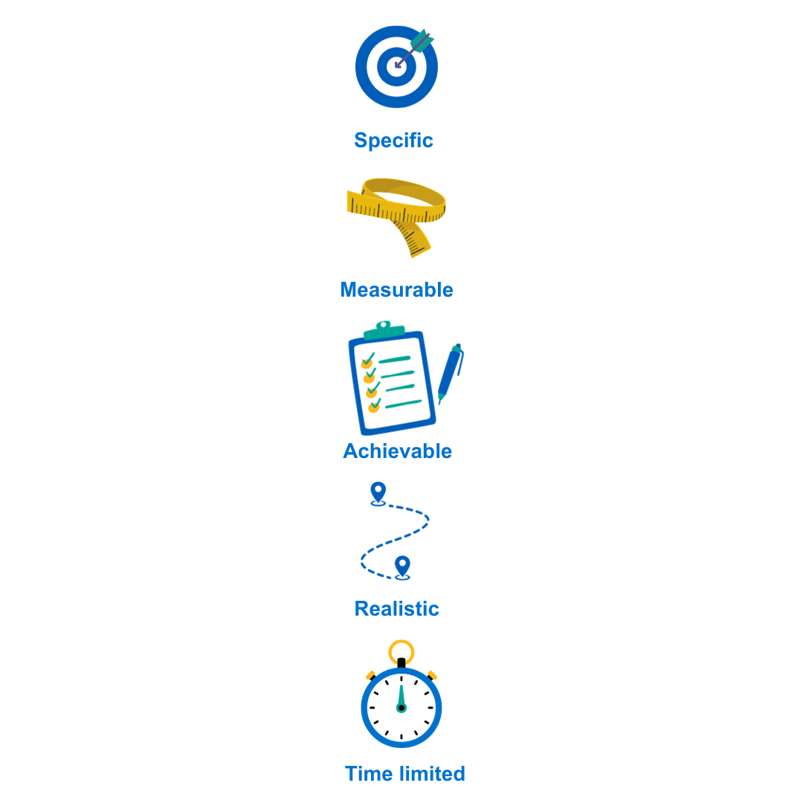

**What do I want to achieve?**

**How will I know I have reached the goal?**

**Can I achieve this goal with the resources I have?**

**Could anyone achieve this goal?**

**When should this goal be completed?**

Using the SMART Goal framework, have a go at setting your own goal for treatment. Have a think about what you’d like to be doing if you were feeling better.

It is important to consider **barriers** to achieving your goal. If there are some barriers, consider what you could put in place to solve them.

**Task**: Set a SMART Goal and consider barriers

**My SMART goal:**

**What might get in the way:**

**How can I overcome this?**

These goals might be short-term or long-term and perhaps right now feel a little daunting, however in session 3 we will look at how to learn further strategies on how to work towards these in a manageable way.

**Between Session Tasks**

Each session, you will be set some tasks for the next week based on the information covered. It is important to practice each task regularly over the next week. This will help you begin to see some improvement in your anxiety.

**Session two tasks:**

1. **Complete values compass**
2. **Start to create a hierarchy of realistic activities in line with your values and set some SMART goals**

**End of session 2 review**

At the end of each session, reflect on what you've learned. Consider how you can apply it to your own situation. Use the prompt questions below to think about what you’re going to spend the next week practicing. Consider some solutions to any barriers that may prevent you making the agreed changes.

* **What did I learn in today’s session?**
* **How can I apply this to my own situation?**
* **What might get in the way of doing this?**
* **How can I stop this from happening?**
* **What am I going to practice from this session?**

**Session 2 - Notes**

**3rd**

**Session**

**Start of session 3 review**

It’s helpful to review the practice you have done over the last week. Don’t be disheartened if you haven’t been able to complete all the tasks. Instead, it is helpful to think about what got in the way and consider how to overcome this next time.

|  |
| --- |
| **How did you get on with the between-session tasks?** |
|  |
| **How do you feel about this?** |
|  |
| **Did you come across any barriers? How did/will you overcome them?** |
|  |

**Activity patterns and pacing**

**‘Boom and Bust’**

Boom and bust is a pattern of activity that a lot of people with pain fall into. It can look like this:



**1**

**2**

**3**

**4**

**Activity**

1. A “good” day with more energy, better mood, and less pain than usual. You feel like things are back to “normal” and decide to make the most of it. You do a lot more activity than your body is used to. You might see friends, do gardening and housework, exercise more than usual.
2. However long this good patch lasts, eventually you will have a bad day, or your symptoms will be aggravated by doing too much. The severity of your symptoms might force you to do less.
3. An increase in symptoms might force you to rest or reduce your level of activity so that you can’t do your normal amount of activity.
4. You can repeat this cycle indefinitely.

**Do you recognise this activity cycle?**

**What do you feel like on a good day?**

**What do you feel like on a bad day?**

**‘Take It Easy’**

Most people who experience pain will have been advised to ‘take it easy’ or rest because of their pain. The people who give this advice have usually got good intentions. Their experience of short-term pain makes them believe that resting will cure whatever is causing your pain. We know that this is not true for long-term pain.

Fear can play a big part in doing less. You might think that pain means that your body is being harmed or damaged. This is very unlikely to be true with long-term pain. You will probably want to avoid doing things that make your pain more noticeable anyway; or even things that might make your pain worse.

Resting for a while and then suddenly doing more than usual can make pain more noticeable. We can believe that it is the type of activity that makes our pain worse and then avoid doing that kind of activity in the future.

Feeling low in mood, or depressed, can make it hard to do things. People who are low often find it easier to avoid doing things like seeing friends, and they are often very tired most of the time.

There are a lot of reasons why you might do less when you are in pain but doing less can lead to you getting stuck in the take-it-easy trap.

**Pacing**

Pacing is a different way to approach how much you do. In Boom and Bust, your LTC might force you to be inactive when you have done too much. If you pace well then you become more able to plan, and the pattern of activity might look more like this line in the middle.



**Activity**

**Time**

**1**

**2**

**3**

On a good day do a little bit less than you are able to; don’t push yourself to your limit.

* Take frequent short breaks
* Break tasks or activities down to smaller actions
* Change position regularly

*Do this Before your LTC symptoms gets worse. Don’t wait until you need to rest or move, rest or move ‘by the clock’. Set a timer to remind you to rest or move and listen to it. Experiment to find out how often you need a rest or a change, it might be every 5 minutes on one day and every 20 minutes on another day.*

* *This protects you from a flare-up that would stop you from doing any activity at all for a while.*
* *You are likely to keep having some days that are better than others, and to do a bit more than usual on those days. However, if you pace* your activity the ups and downs are not so dramatic.

Pacing means finding a balance of activity by limiting how long you spend on an activity. This stops big increases in symptoms and makes sure you keep to a regular amount of activity to prevent the problems of too much rest. This helps you to plan activity instead of doing things based on how you feel.

**Examples of Pacing**

**Here are some examples of pacing:**

* 1. If you find that doing half an hour of work in the garden without stopping is enough to give you a lot of pain, you could do 15 minutes. Then go and do something else, perhaps something less physical, such as sit down and have a cup of tea, read the paper, or make a phone call. Then go back later to do another 15 minutes. You still do 30 minutes of gardening in the day but without the same increase in pain and without ruining your day.
  2. If standing and ironing leave you with a lot of pain, you could sit on a stool and do 2 or 3 items at a time. By doing small amounts of ironing at a time over a day or two will mean that the ironing gets done but without the same increase in pain.

## Planning

Planning is deciding **when and how you are going to do things**. Think about what kind of activity you do, and how it is spread out over hours, days, weeks and months.

Make sure that activities you find difficult are spread out. You can use copies of the activity diary to help you to plan.

Try to get a **balance** of things you’ve got to do and things you enjoy doing every day.

It can be helpful to think about what is physically involved in an activity you are thinking about doing. For example, don’t forget to think about how much travel is involved.

**Plan breaks** and give yourself enough time to **finish the activities** you are planning to do. Try not to compare what you can do now with how you used to do things.

## Prioritising

Prioritising activities **means making choices about what you do**. You will need to think about what needs to be done as well as what you would like to be doing. It's important to make time for things that give you pleasure. You should balance tasks that need to be done with activities for interest and pleasure. You may need to consider what has to be done today or sometime this week and what can wait a while. **Ask yourself what is really important.**

There may be times when you choose to do something knowing you will ‘pay the price’ and have a lot of pain afterwards because other things can sometimes be really important to us, for example, attending a family wedding. Although this may be a choice you make it can be particularly helpful to consider how you pace and manage your pain before and after the event.

**Summary Points**

* You may not be able to do everything in the same way or at the same pace as you did before.
* You do not necessarily have to stop doing things due to your illness, but you may have to consider doing things differently and change your approach to activities depending upon your ability.

**Top tips:**

* To understand pacing, it can help to think of your available energy as being like a mobile phone battery. If you completely drain the battery you have to wait to recharge it before you can use the phone again. ​
* If you use *some*of the battery and make regular top ups, then your phone will always be ready for use. ​
* Managing your energy means planning periods of activity and rest. Doing this based on time will mean you are more likely to do the activities you want to do.

**Remember…**

When living with a long-term condition there are times when we feel that some things are unachievable. It can be helpful to break activity down into smaller steps in order to feel less overwhelmed.

When we are depressed or sad, it can take a lot of effort to do even small tasks. This is why it is important to make the tasks we set ourselves realistic.

It may be helpful to increase activity in a gradual way step by step. This means the changes we are making are realistic for us. We can build on them to make them easier. This will build confidence in our ability to cope with daily challenges such as household tasks, running errands, and seeing friends. Other challenges may include going to work, keeping appointments, answering the phone, and replying to texts.

**Task 5: Planning ahead using pacing**

|  |  |  |  |
| --- | --- | --- | --- |
|  | **Morning** | **Afternoon** | **Evening** |
| **Monday** |  |  |  |
| **Tuesday** |  |  |  |
| **Wednesday** |  |  |  |
| **Thursday** |  |  |  |
| **Friday** |  |  |  |
| **Saturday** |  |  |  |
| **Sunday** |  |  |  |

**Task 6: Functional Equivalence**

Another way to consider how to do activities differently is functional equivalence. When people have a long-term condition, it can mean they are unable to physically do activities they used to do, and this can be really difficult to adjust to especially if the activity was important to you.

So, what we can do is think about the **‘function’ or ‘purpose’** of that activity you can no longer do and think about other activities that serve the same function. Here is an example:

|  |  |
| --- | --- |
| **Activity** | **Function** |
| Meeting a friend for a walk and coffee | * Socialise with friends * Exercise for health benefits |

Now let’s consider other activities that serve the same function:

|  |  |
| --- | --- |
| **Function** | **Other activities** |
| Socialising | * Meeting at a coffee shop * Arranging a telephone call with friend * Arrange a catch up at my house |
| Exercise | * Physio exercises * Meet for a shorter walk with planned rest breaks (i.e. benches at the park) |

Although the activities are different and may not give the same enjoyment or experience as the original activity, it still gives a sense of pleasure and enjoyment by doing things that serve the same purpose and allows to connect with others. It is important to make adaptions to the things you may no longer be able to do and focus on the things you are physically able to do.

**Functional Equivalence**

**Task 6: What activities can I do differently?**

Considering your values and functional equivalence, have a go at completing the table below:

|  |  |  |
| --- | --- | --- |
| **Activity I used to be able to do** | **Function** | **Other activities serving same function** |
| *e.g. Drive to do big food shop on my own* | *Independence* | *Online food shop* |
|  |  |  |
|  |  |  |
|  |  |  |
|  |  |  |

**Between Session Tasks**

Each session, you will be set some tasks for the next week based on the information covered. It is important to practice each task regularly over the next week. This will help you begin to see some improvement in your anxiety.

**Session 3 tasks:**

1. **Practice pacing, planning and prioritising considering your values and goals from session.**
2. **Try doing activities differently using functional equivalence.**

**End of session 3 review**

At the end of each session, reflect on what you've learned. Consider how you can apply it to your own situation. Use the prompt questions below to think about what you’re going to spend the next week practicing. Consider some solutions to any barriers that may prevent you making the agreed changes.

* **What did I learn in today’s session?**
* **How can I apply this to my own situation?**
* **What might get in the way of doing this?**
* **How can I stop this from happening?**
* **What am I going to practice from this session?**

**Session 3 - Notes**

**4th**

**Session**

**Start of session 4 review**

It’s helpful to review the practice you have done over the last week. Don’t be disheartened if you haven’t been able to complete all the tasks. Instead, it is helpful to think about what got in the way and consider how to overcome this next time.

|  |
| --- |
| **How did you get on with the between-session tasks?** |
|  |
| **How do you feel about this?** |
|  |
| **Did you come across any barriers? How did/will you overcome them?** |
|  |

**When Thoughts become Unhelpful**

The way that we think about, or interpret, an event will decide how we feel about it. Often experiencing something that we think of in a negative or frightening way (like pain) can lead to low mood and anxiety.

When we are low or anxious we are more likely to experience Negative Automatic Thoughts (NATs). NATs are:

**Believable:** we tend to believe our thoughts and take them as facts. A fact is something that is proved to be true, it can’t be interpreted differently by different people. **Remember, thoughts are not necessarily true, accurate or helpful.**

**Automatic:** most thoughts are automatic and arrive in our mind without us choosing them.

**Persistent:** thoughts can repeat in our minds which can make them feel believable.

**Distorted:** thoughts can pull events out of shape and give us a false impression of what is happening.

**Tip: Sometimes negative thoughts are factual; for example, ‘My back hurts’ might be factual but spending time dwelling on it might not be helpful. We don’t challenge factual thoughts, but you can distract yourself from them if they are affecting your mood.**

**Unhelpful Thinking Styles**

When we think in unhelpful ways, there tends to be common patterns. These patterns are known as unhelpful thinking styles.

|  |  |  |
| --- | --- | --- |
| **Name** | **Description** | **Example** |
| **Overgeneralising** | Seeing negative things as a never-ending pattern of defeat. | *Symptoms stop you from going for a walk one week, so you think ‘I can’t ever go for a walk’* |
| **Mind Reading** | Assuming what others are thinking without knowing it. | *They think I should try harder* |
| **Negative Mental Filter** | Seeing all situations through a negative lens. | *They said the scan was normal, but I think they missed my problem* |
| **Catastrophising** | Imagining the worst-case scenario. |  |
| **All or nothing thinking/Black or white thinking** | You are more likely to think of things as all good or all bad, with nothing in the middle/grey area. | *I didn’t finish everything that I should have done today so nothing good happened* |
| **Memories** | Memories of previously distressing episodes can cause us to believe danger is here and now rather than in the past, causing us distress right now. | *The last time I had this type of pain, I ended up in hospital* |
| **Emotional Reasoning** | Going with how you feel. | *I feel something is wrong so there must be something wrong* |

**Cognitive Restructuring**

Cognitive restructuring is an evidence-based technique. It can help by changing unhelpful thoughts to more balanced ones. When thoughts are more balanced, they are less distressing. ​

Cognitive restructuring is not about creating motivational quotes or thinking positively. It is about thinking in a more realistic way to reduce the connection between low mood and thoughts.

**Step 1: Catching Thoughts**

The first step of challenging unhelpful thoughts is to begin to notice unhelpful thinking that can lead to heightened low mood or anxiety​. This can help increase awareness of your thought processes. The more aware you are, the easier it will become to challenge. Try to be curious without being self-critical.

Using the task on the next page, try and keep a thought diary where you notice the emotion associated with the thought and the intensity.

Try and write down thoughts as soon as possible​ so you don’t forget.

**Task 7**: Thought Diary

|  |  |  |  |
| --- | --- | --- | --- |
| **Situation** | **Thought (% belief)** | **Emotion**  **(% intensity)** | **Unhelpful Thinking Style** |
|  |  |  |  |

**Step 2: Identifying Unhelpful Thinking**

Try and identify the “hot thought” from the thoughts you have collected. The “hot thought” is the part of the thought that gives you an instant negative reaction e.g. “I’m going to lose my job” or “my manager thinks I’m stupid”.

You can use the unhelpful thinking styles on page 6 to help you spot some automatic thoughts.

**Step 3: Challenging Unhelpful thinking**

Once you have identified some unhelpful thoughts, you can challenge them by trying to find evidence **for** and **against** the thought being true. This helps highlight that thoughts are not facts.

Imagine you are presenting your hot thought in a court room. You need to consider evidence that the thought is true and evidence the thought is false. Below are some questions you can ask yourself to help gather evidence:

* Is this fact or opinion?
* Would I still believe this thought if I didn’t feel so anxious or low?
* Is my reaction in proportion to the event?
* What would I say to a friend if they were in a similar situation?
* How will I think about this in 5 years tIme?
* What will happen if I continue to think this way, is it stopping me enjoy life?
* What is a more encouraging or useful way of thinking?
* Is there something I can learn from this situation, to help me next time?

**Task 7**: **Challenging thoughts continued…**

Choose a thought to challenge from your diary. Rate how much you believe the thought out of 100%. Then, find evidence that the thought is true or false (evidence for and evidence against).

|  |  |
| --- | --- |
| **My thought to challenge** | **Belief in thought %** |
| |  |  | | --- | --- | | **Evidence the thought is TRUE** | **Evidence the thought is FALSE** | |  |  | | |  |

**Step 4: Balancing thoughts**

You can now use the evidence you have gathered to create a **balanced thought** based in **fact.** Include as much evidence from the true and false column as you need to create a believable thought.

|  |
| --- |
| **My balanced thought** |
|  |

**Step 5: Reviewing Balanced Thoughts**

How does the new balanced thought compare with the old hot thought? Using the table below, you can rate not the belief in the hot thought **before** you created a balanced thought, and **after.** Compare the difference, what do you see?

The aim of cognitive restructuring is not to bring your belief in the original thought to absolute zero. It's important not to expect this straight away as you may feel like you've failed and increase the unhelpful thoughts you are experiencing.​

Research about Cognitive Restructuring tells us that even a small shift in belief and distress is good enough. Hopefully, you'll feel a slight improvement as a result. ​

**The more you practice, the more you will feel confident with your thought challenging.**

**The more you practice, the more you can reduce the belief and distress.** ​

**Task 7:** Reviewing thoughts.

|  |  |  |  |
| --- | --- | --- | --- |
| **Original Thought** | **My balanced thought** | **Belief Before %** | **Belief After %** |
|  |  |  |  |

**Cognitive Restructuring: A Summary**

* Writing thoughts down can be helpful.
* Putting your thoughts on trial helps you find balanced alternatives.
* Use the prompts in the thought diary to help find evidence against your hot thought.
* Practice, practice, practice!

Once you have identified some unhelpful thoughts, you can challenge them by trying to find evidence **for** and **against** the thought being true. This helps highlight that thoughts are not facts.

**Rumination and the two-minute rule**

Thinking about the past can be fun and helpful. You can **reflect** on things that have happened and learn from them. Some people **reminisce** or enjoy re-living happy memories. Sometimes thinking about the past can become **rumination**. Rumination means going over bad things that have happened in the past, painful thoughts and feelings and troubling memories. When you ruminate you might have a lot of ‘If only…’ or ‘I wish that I…’ thoughts.

Rumination makes your mood worse and makes you less willing and able to solve problems. When you ruminate you don’t pay attention to what is happening right now but concentrate on things that happened in the past. **The two-minute rule** can be helpful if rumination is getting in the way of doing things that help you.

**The Two Minute Rule**

Once you notice that you are thinking about problems, continue for 2 minutes and then ask yourself:

* **Have I solved a problem, or started to solve a problem?**
* **Do I understand something that I have not understood before?**
* **Do I feel less critical or less depressed than before I started thinking about this?**

If the answer to these questions is ‘no’ then this is unhelpful rumination- use this as a cue to action. Notice what is around you or distract yourself with a different activity. This should help to break the cycle. Do something different!

**Being Kind to Yourself**

What you say to yourself in your thoughts is important, and so is how you say it. You might tell yourself something true and balanced instead of an unhelpful thought. But, if your mental voice or attitude is angry, demanding, judgmental, or blaming, then changing thoughts wont much affect how you feel. If you can talk to yourself in a kind way, it’s likely to make more difference.

Being kind to yourself is sometimes called self-compassion. It means not ignoring things in your life that are difficult, instead you could

* Notice your difficulties and don’t judge yourself for them.
* Acknowledge that everyone, including you, will struggle, fail, make mistakes and feel bad about themselves sometimes. This is one of the things that makes us human.
* Do things for yourself that you would do for a good friend.

It’s easier to be kind when you feel better in your mood. Something that can help you to feel better is a diary.

## Task 8: The kindness diary

* Keeping a daily diary of things that are joyful, pleasant or that feel like achievements.
* Record three things every day; this could be small things like sunlight, a smile from someone, cooking your favourite meal, a nice texture or smell.
* Make it personal: use a notebook, notes in your phone, a box of nice objects, photographs, recordings.

**Note: When you are low in mood, stressed, anxious and bothered by physical symptoms that are worse than usual you can find it difficult to remember the good things that have happened in your life. Keeping the diary means that you can get to these memories easily when you need them.**

**The stages of sleep**

The diagram shows a typical night’s sleep for an average adult. The times at the bottom are just suggestions to give a sense of how long bits of sleep might take, not saying we all go to bed at the same time.

We have several cycles of sleep during a typical night. During each cycle we experience different **stages of sleep** – these are down the left side of the graph. A whole cycle lasts for about 90-120 mins, we might have two whole cycles in a night and then lighter sleep when we have more REM stage sleep.

**Stages 1 & 2** lighter levels of sleep. Stage 1 is very short. We are conscious of thoughts and easily woken. Stage two is a little deeper, our heart rate slows but we still wake easily.

**Stages 3 & 4** are the most restorative and refreshing stages of sleep, body temperature & blood pressure reduces, body repairs at cellular level, harder to awake.

**REM** – Rapid Eye Movement - Heart rate and blood pressure increase, survival reproduction systems ‘rehearsal’, likely to dream during this stage but our body is paralyzed so that we can’t act out our dreams.

**Partial waking** – happens several times a night. We usually don’t realise that we’ve woken up and go straight back to sleep unless something grabs our attention.

**What can affect your sleep?**

* Pain and discomfort
* Focusing on pain
* Active mind/worrying
* Reactions to sleep disturbances
* Lack of routine getting to sleep
* Lack of routine when waking in the night
* Emotional states e.g. anxiety, depression
* Day time napping
* Food and drink
* Activity and exercise patterns
* Environmental factors e.g. light, temperature, noise

**What tools could you use to manage some of the things that affect your sleep?**

**Task 13: Sleeping Tips**

* Even if you have had a bad night’s sleep the night before try not to have naps in the daytime. Napping during the day will make it harder to sleep at night.
* Take some time to relax and wind down before going to bed. Try to get into a routine of doing certain relaxing activities before bedtime, for example soaking in a warm bath, reading a book or listening to music.
* Do not do anything mentally demanding 90 minutes before going to bed.

* Use the bed just for sleeping; avoid watching TV/using laptops or your phone in bed as the light and subject matter may inhibit sleep.
* If you wake in the night avoid looking at the clock to see what the time is, you could try turning the clock away from the bed so that you cannot see the time.

## The Sleep Checklist

## Alcohol

A lot of people drink alcohol before they go to bed because they think that it helps them to get to sleep. Alcohol is a muscle relaxant so it can help to reduce how much you worry and might make it more difficult to notice symptoms for a little while. Unfortunately, alcohol has a bad effect on sleep; it stops you from getting into the deeper stages of sleep and makes you more likely to wake up for longer when you have a wakeful moment at the end of a sleep cycle. Alcohol might make you less likely to move your body when you are asleep, and this can lead to stiffness which could make pain feel worse.

The Health Service recommends not drinking more than 14 units of alcohol a week and do not drink alcohol for four hours before you try to sleep. If you are not sleeping well then you could experiment with not drinking any alcohol at all, to see if your sleep improves.

## Caffeine

A lot of drinks and food have got caffeine in them: tea, coffee, energy drinks, many fizzy drinks, chocolate and painkillers are some examples. Caffeine makes your body ‘wake up’; it prompts your heart to beat faster and your muscles to tense up. If your body is stimulated in this way it makes it difficult to fall asleep or to be rested by sleep. Caffeine can stay in your body for six hours.

Try not to drink or eat anything that might have caffeine in it in the afternoon.

## Eating before bed

Eating a big meal just before going to bed can make you feel over – full, and your body needs to work to digest the food, so this can interfere with sleep. Going to bed when you feel hungry might also make it difficult to drop off.

Try to eat your evening meal earlier in the evening and having a small snack like a slice of toast or a milky drink before bed.

## Watching TV, using computers or playing electronic games

Most screens project blue light which will keep your brain active, this would stop you from feeling tired. You could think about what you are watching on the screen – is it, frightening, exciting or stimulating? This could get in the way of sleep.

Try not to use screens for an hour before you go to bed and try not to use screens in your bedroom.

**Activity levels**

Being active is good for your health and is an important part of managing pain. The Health Service recommend trying to spend twenty to thirty minutes a day moving gently but enough to make you slightly out of breath (so that you could still talk to someone). Activity and movement will make your body warmer and can give you a feeling of increased energy. When you are going to sleep your body tries to cool down so activity just before bedtime can make it harder to get to sleep.

Try to do some gentle activity on most days but give your body time to cool down before you try to sleep.

**Smoking and vaping**

Just like caffeine, nicotine is a stimulant and makes it harder to fall asleep and to stay asleep. Try to avoid cigarettes for at least 2 hours before bed.

**Naps during the day**

When you sleep for several hours during the day you will need less sleep at night. Sometimes people expect to sleep for a certain number of hours at night, even if they have taken some of their sleep during the day. When they sleep for fewer hours than they expected to they begin to worry and feel distressed.

Try to be aware of how much sleep you tend to need during twenty-four hours. If your symptoms are making it difficult to sleep at night, it might be helpful for you to have a nap in the day. Remember that if you take some of your sleep during the day, expect that you might need less at night.

**A routine if you wake up in the night**

We all wake up several times during a typical night, usually we will fall asleep again without remembering this but sometimes pain or worry can catch our attention and keep us awake. If you wake during the night, it can be helpful to plan what you will do at those times.

Try to have a plan of what you will do if pain wakes you up. You could walk around the house or do some gentle stretching exercises to make your muscles and joints less stiff. You could do a relaxation exercise. You could sit in another room and do something boring until you feel drowsy again.

If your LTC is keeping you awake you might need to lay in bed and rest as deeply as you can, even if you can’t sleep.

**Between Session Tasks**

Each session, you will be set some tasks for the next week based on the information covered. It is important to practice each task regularly over the next week so you can begin to see some improvement in your anxiety.

**Session 4 tasks:**

1. **Try out thought challenging.**
2. **Practice self-compassion by using a kindness diary.**
3. **Review behaviours which may impact on sleep and identify any changes that can be made.**

**End of session 4 review**

At the end of each session, reflect on what you've learned. Consider how you can apply it to your own situation. Use the prompt questions below to think about what you’re going to spend the next week practicing. Consider some solutions to any barriers that may prevent you making the agreed changes.

* **What did I learn in today’s session?**
* **How can I apply this to my own situation?**
* **What might get in the way of doing this?**
* **How can I stop this from happening?**
* **What am I going to practice from this session?**

**Session 4 - Notes**

**Session**

**5th**

**Start of session 5 review**

It’s helpful to review the practice you have done over the last week. Don’t be disheartened if you haven’t been able to complete all the tasks. Instead, it is helpful to think about what got in the way and consider how to overcome this next time.

|  |
| --- |
| **How did you get on with the between-session tasks?** |
|  |
| **How do you feel about this?** |
|  |
| **Did you come across any barriers? How did/will you overcome them?** |
|  |

**What is self-management?**

Self- management is all of the actions taken by people to recognise, treat and manage their own health. This can include physically, psychologically, and the social aspects of living with a long-term condition. Making changes that aim to maintain a satisfactory quality of life.

**What does good self-management look like to you?**

**Gathering information about your LTC**

Effective self-management means having access to up-to-date information about your condition, knowing about your own health problems and what may lead to a flare-up or a setback in symptoms and knowing when treatments are appropriate.

It can be helpful to be able to recognise what symptoms are related to your condition so you can spot any warning signs or changes that may need medical attention. It is also useful to be able to know what is expected in terms of your role of managing your condition.

Information about your LTC can come from lots of different sources, these can include:

* **Your GP**
* **Nurse specialist**
* **Consultant**
* **Other healthcare professionals**
* **Support groups**
* **Trusted websites**
* **Self-help books**

The table on the next page can help you gather this information.

**Task 10: Who’s Who?**

Use the below table to write down any health care professionals you have contact with to help keep track of who can help and when:

|  |  |  |  |
| --- | --- | --- | --- |
| **Name** |  |  |  |
| **Job Title** |  |  |  |
| **Contact number and when are they open** |  |  |  |
| **When to make an appointment?** |  |  |  |
| **What can they help with?** |  |  |  |

**Managing medication**

Medication can be used for managing symptoms of your long-term health condition as well as managing your mood. When we are prescribed medication we may be ‘passive’ participants – just doing what we are told, but it is important to ask questions about the prescribed medication in order to feel in control.

Here are some ways to help you feel in control and self-manage medication:

* When additional medications are prescribed – always check what these are for and ensure they are in a repeat prescription from your GP. **Do you know why you are taking the drugs that have been prescribed? How will they help?**
* Medication is not static: guidelines can change as medical research develops and the understanding of diseases is improved. **Seek reliable information about medication**. Not the internet. Talk to a Doctor or pharmacist or nurse prescriber.
* Have a day-to-day plan or some strategies so that you are more likely to remember to take your medication. **Make sure you know what you’ve taken and when. What do you need to do if you miss taking your medication?**

​​

**Fears and worries** about taking medication are really normal.

For example, you might worry about **side effects**. It can help to have an understanding of the common side effects of each medication. This will help you to do a **cost-benefit analysis** to see if the benefit of the medication is worth the side effects.

**Self-Management**

Self-management of your health condition means being aware of and doing things to look after yourself and that can help to improve your day-to-day functioning. This can involve:

* Having awareness of your capabilities and willingness to push yourself to engage in looking after yourself.
* Being an active participant in the management of your condition. This might include finding support, asking for help, lifestyle changes, monitoring symptoms and keeping track of what helps. ​
* Being aware of any changes in your symptoms: keeping a diary can help with this to help notice any patterns.

**Things that can help with managing symptoms:** recognising changes that are needed because of your symptoms and how they are now, following medical advice, learning what triggers/worsens your symptoms​.

​

Engaging in activities that promote health and wellbeing e.g. healthy diet, activity that is within your physical limits, using the tools covered in this course​.

​

Self-management is the opposite of poor coping where you might be avoiding lots of situations or even avoiding thinking about the illness. ​Self-management is not easy and can be frustrating at times.  ​

**Use the space below to reflect on your self- management:**

**Task 11: Communication Styles**

Communication is how we convey or share ideas, feelings and information. We usually think about communication being verbal; that is, using words. However, we know that most of what we communicate to others is passed through non-verbal signals. These include tone, voice volume, body language, movements, and facial expressions.

There are four communication styles that we all use. What is happening in our life will affect our style of communication. So will our thoughts, feelings, and the people we talk to.

Each communication style is characterised by different non-verbal signals. They tend to be prompted by different kinds of thinking and will elicit different reactions from the other person in the conversation.

**The four main communication styles are:**

**•      Passive communication**

**•      Aggressive communication**

**•      Passive-aggressive communication**

**•      Assertive communication**

|  |  |
| --- | --- |
| **Passive** | Not expressing your thoughts, feelings and opinions,  and believing that others’ views are more important than your own.  Tending to avoid conflict and seeking to gain approval of others. |
| **Assertive** | Expressing your feelings, thoughts and opinions in an open, direct and honest manner, whilst standing up for your rights and respecting those of others. |
| **Passive aggressive** | A style in which individuals appear passive on the surface but are really acting out anger in a subtle, indirect, or behind-the-scenes way.  People who develop a pattern of passive aggressive  communication usually feel powerless, stuck, and resentful. |
| **Aggressive** | Expressing your thoughts, feelings and opinions in a demanding and angry way.  You believe that your own needs are more important than others and therefore ignore and dismiss other’s needs. Talking over/ interrupting other people. |

**The Rules of Being Assertive**

There are certain beliefs that people who use assertive communication hold. If you can learn to believe that these statements are true about both you **and other people,** it will be easier to communicate in an assertive way.

**I have the Right to:**

* Respect myself
* Recognise my own needs as an individual
* Make clear ‘I’ statements
* Allow myself to make mistakes
* Change my mind, if I choose
* Ask for thinking it over time
* Say No
* Allow myself to enjoy my successes
* Ask for what I want, rather than hoping someone will notice what I want
* Recognise that I am not responsible for the behaviour of other adults
* Respect other people and their right to be assertive and expect the same in return

**How often do you act in this way and use these rights?**

**Top tips for communicating assertively**

* Be honest with yourself about your own feelings
* Keep calm and stick to the point
* Be clear, specific and direct
* If necessary, keep repeating your message whilst also listening to the other’s point of view.
* Explore alternative solutions with the other person if appropriate
* Ask if you are unsure about something
* Script what you want to say
* Try to stand back and see it from their point of view

**Saying “No”**

When you experience a long-term condition, you are likely to be in situations where you are asked to do things that you are no longer able to do. Being able to say ‘no’ in a calm and assertive way can be very helpful.

**How to say ‘no’**

* Be clear on what you are being asked. If in doubt, ask for time or more information.
* Be direct in your answer. Use the word “No” in the sentence.
* Be honest. You can give a simple reason for saying ‘no’ if you want to.
* Be firm, stick to your “No.” Other people’s limits will differ from your own and some people might ask a few times.
* Be equal: Allow the person to be upset by your answer; that is their right. You could say “I am sorry you are upset by my answer, but it is still “No.”
* Be sure and don’t hint that you might change your mind.
* Be kind - stress that it is the request that is being turned down, not the person.

**What makes it difficult to say no?**

**What tools from the course could you use to manage these reasons?**

**Making the most of your Healthcare Appointments**

**Before you go**

* Think about what you want to get out of the appointment
* Plan and write down the main questions you want to ask (try not to take a very long list to an appointment)
* Put your list in order of priority
* Think about whether you want to take someone with you

**During the appointment**

* Be clear about the questions you want to ask or the things you would like to discuss at the beginning of the appointment. It might not be possible to cover everything in one appointment, and you and the doctor can then plan which are the immediate priorities.
* It can be helpful to make some notes to help you remember what is discussed.
* Before you leave check that you have understood the next steps e.g. any changes to your medication, any referrals that will be made, when you will be seen again and why.
* You could ask your doctor to direct you to some useful information e.g. leaflets, websites.
* You might be able to get information or answers by phone or post and remember that others working in a clinic (nurses or physiotherapists for example) might be able to help you.
* It’s helpful if you show that you consider yourself to be a partner in your medical care.

**How to ask for what you need**

Sometimes you will need to ask for something, but you will feel like it is difficult or frightening to ask. Scripting is a way to plan what you want to ask and to speak to the other person in a clear and direct way. You can write your script down beforehand and keep it with you or memorise it, whatever works best for you.

1. **Describe what has happened** e.g. I’ve noticed a new pain in my shoulder.
2. **Describe how this makes you feel** e.g. I feel frightened that this pain is going to keep getting worse.
3. **Describe what you are asking for** e.g. It would be helpful if you could examine my shoulder and explain why it is hurting, how long the pain might last and what I can do about it.
4. **Describe what will happen if you get what you have asked for** e.g. If you can give me this information, I’ll be relived and more able to look after myself.

**Scripting**

Sometimes you will need to ask for something, but you will feel like it is difficult or frightening to ask. Scripting is a way to plan what you want to ask and to speak to the other person in a clear and direct way. You can write your script down beforehand and keep it with you or memorise it, whatever works best for you. There are four parts to think about: the **events, feelings, needs** and **consequences**.

* **Events:** Describe what has happened. Be specific.
* **Feelings:** Describe how this makes you feel. Expressing your feelings clearly can prevent a lot of confusion, and no one can argue with the way you feel.
* **Needs:** Describe what you are asking for. People are not mind-readers, so being clear about what you needs helps them to understand.
* **Consequences:** Describe what will happen if you get what you have asked for. Be specific about the positive consequences.

**Example**

**GP:** ‘Hello, Rosemary. What’s the problem?’

**Rosemary:** ‘Hi, Dr Jones. I’ve noticed a new pain in my ankle **(event)**, and I’m worried that it’s caused by my osteoarthritis. I’m scared that my mobility will get even worse and it might stop me walking completely **(feelings)**.’

**GP:** ‘Ok, tell me about the pain. Does it feel the same as the pain you have in your hip, which we know is caused by the osteoarthritis?”

**Rosemary:** ‘Yes, it feels like my hip did when it started. It would be helpful if you could examine my ankle and explain why it’s hurting. I’d also like to know how long the pain might last and what I can do about it **(needs)**. If you can give me that information, I’ll be more able to look after myself **(consequences)**.’

**Mindfulness**

Mindfulness means paying attention in a particular way:

* On purpose
* In the present moment
* Non-judgemental

By being mindful we choose and learn to control the focus of our attention. When we worry, we tend to think about the future, trying to anticipate and solve hypothetical problems. Practicing mindfulness will help you to be more grounded in the present moment and to spend less time worrying.

* A good way to start to practice mindfulness is to start with some routine activities you do (e.g. washing the dishes) and to carry them out mindfully instead.

You can learn how to practice mindfulness by using the Headspace app, reading Mindfulness for Health by Vidyamala Birch and Danny Penman, or using a website like **Freemindfulness.org**. There are a number of courses available that will teach you how to be mindful. Ask your course facilitators or practitioner for details of these.

**Mindful activity**

|  |
| --- |
| My activity: |
| During the activity focus on the following:  Touch:  Sight:  Hearing:  Smell:  Taste: |
| What did I learn from this task? |

**Moving forward after the course**

There is no right or wrong way to feel at this point in the course. You may be feeling better and ready to finish treatment. You may not be feeling better and wanting to explore further treatment options. You may be somewhere in between.

To plan for the future beyond this course effectively, you need to think about how things have changed since the first session.

Research tells us that it is common for problems like anxiety and depression to return after feeling better. This is called lapsing and relapsing. While this may seem daunting, it is important to note that this is normal.

It can be helpful to consider what thoughts, feelings or behaviours could be warning signs that you were feeling worse again. When you are more aware of them, they can be stopped quickly and more effectively.

Using the task below, consider noticeable thought patterns, physical feelings behaviours or situations that might trigger low mood or anxiety.

**Task 16: My Warning Signs**

|  |
| --- |
| Situations:  Thoughts:  Physical feelings:  Emotions:  Behaviours: |

**Task 17: My Wellbeing Action Plan**

Think about the things you have changed over the past five weeks and make a plan of what you will do in the future if needed.​

While it is recommended to keep up all of the techniques you've learned, it is normal for them to not be needed after a long period of feeling better. Sometimes they just become automatic e.g. thought challenging. Taking the time now to remember what helps can help you restart anything you stop doing should you need to in the future. ​

Consider a time to check back in with the wellbeing plan to make sure it's still being followed or if any changes can be made. The length of time is up to you. ​

Even if you aren’t feeling better, it is helpful to think about what has been helpful and what you'll keep trying as you move forward with treatment – no matter how small.

**What has been working well?**

**What helped last time?**

**What can I do now?**

**What can I continue doing?**

**Reviewing goals**

During the course, we have discussed how setting goals can help to move forward Have a look back at some of the goals you set and think about how far you are from achieving it. You may have already done it, be part of the way there or not be close at all.

With this in mind, think about what you’d like to aim towards now the course is over. It could be the same as what you thought of in the beginning or a slightly revised version; it could be something different completely.

​You may wish to set a goal for further support or treatment, in these cases, it is helpful to use the 5 Areas Model to think about which specific areas need work.

**Task 18: My goals moving forward**

|  |
| --- |
|  |

**Next Steps**

The next steps of treatment will depend on how you are currently feeling:

Based on the symptoms from your last questionnaire scores, you may be offered a review call. We will discuss alternative options for treatment. This will be offered a few weeks after the course has ended. If you are not offered a review call, you can contact our admin team to request it.

**End of session 5 review**

At the end of each session, reflect on what you've learned. Consider how you can apply it to your own situation. Use the prompt questions below to think about what you’re going to spend the next week practicing. Consider some solutions to any barriers that may prevent you making the agreed changes.

* **What did I learn in today’s session?**
* **How can I apply this to my own situation?**
* **What might get in the way of doing this?**
* **How can I stop this from happening?**
* **What am I going to practice from this session?**

**Session 5 - Notes**